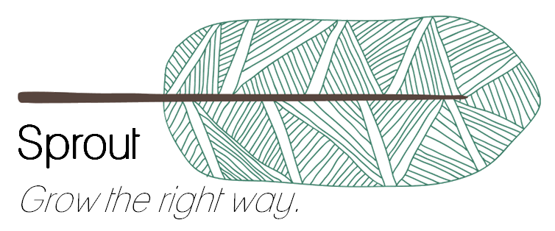

**SPROUT**

**FINAL BUSINESS PLAN**

**Ariston Lim**

**Hung Nguyen**

**Julio Candela**

**Nejada Karriqi**

**Valdemar Hernández**

**VIABILITY OF BUSINESS PROJECTS**

**JUNE 2020**

**TABLE OF CONTENTS**

**1. Introduction, sector, company and products** **4**

A. Sector, company, products or services to commercialize. 4

B. SWOT analysis, Porter model or similar. 6

C. Competitive advantages. 10

D. Mission and basic strategic approach of the company, viability conclusions 10

**2. Market research and analysis** **12**

A. Potential customers (segments and volume) 12

1. Qualitative Research 12

2. Quantitative Research 13

B. Market size and tendencies (consumers’ expected behaviour) 15

C. Existing competitors (lessons learned) 15

D. Sales Prediction and market share 17

**3. Marketing Plan** **18**

A. General Marketing Strategy (segmentation, targeting and positioning) 18

B. Price policy (P2) 18

C. Organization of sales and distribution (P3) 19

D. Product, Service and guarantees policies (P1) 19

E. Advertising and promotion (P4) 20

1. Customers 20

2. Farmers 21

**4. Design plans of the new products / services to develop and Operations Plan** **22**

A. Situation of the design of the product / service, expected problems. 22

B. New future designs. 22

C. Development budget per product or service line 23

D. Geographical location of the productive activities or the service logistics 24

E. Necessary installations, detailed description and technical features 24

F. Production strategy (self-production, outsourcing, etc.) 24

G. Prototype 24

**5. Management Team and staff structure** **30**

A. Organization and people, organization chart and profiles. 30

B. Key directors, profiles and individual CV. 30

C. Directors’ shares remuneration and contribution 39

D. Board of directors 39

E. Professional support services to hire 39

**6. Business project beginning calendar (detailing the first 12 months).** **40**

**7. Risks and critical problems we can find when implementing the plan and possible solutions.** **42**

**8. Financial Plan** **45**

A. Profit & Loss Statement Forecast (2-3 years). 45

B. Treasury Forecast (for the first 12 months). 46

C. Balances Sheet Forecast (2-3 years). 47

D. Break-even analysis (first year). 49

E. How we will manage Cost Control (description of the system to use). 50

**9. Proposal for the investors** **51**

A. Financial needs through other shareholders (different than founders). 51

B. Final composition of shareholders 51

**References** **54**

# 

# 1. Introduction, sector, company and products

## A. Sector, company, products or services to commercialize.

In the last few years, the demand for organic food has shown a growing tendency over traditional products. More people are changing their habits and migrating to healthier and more ecological sources thereby increasing the consumer’s interest for organic products. By definition, these products are related to organic farming which consists of a natural technique to cultivate plants using organic manure and avoiding the ingestion of polluting chemicals such as pesticides and synthetic fertilizers [1].

In fact, the fast development of this sector was guided by some megatrends as the growing consumerism, a bigger awareness for the environment and equality, and shifting to healthier lifestyles [2]. Many companies have been associating these megatrends with the concept of “organic” in order to create more powerful brands for the customers.

Precisely, organic food was well received in Spain and its most important cities. The organic spanish market registered an increase of 12.5% in 2017 which can be translated into 1.6 billions of euros more earnings regarding the last year [1.3]. As a consequence, Spain consolidated its position as one of the most prosperous markets for these kinds of products. According to research about organic food consumption, the main reasons why Spain has a promising future in this sector are the rich ecosystem, the favorable weather and the moderate need of agro-chemicals on the ground in order to cultivate and harvest a wide variety of production [4]. In the next few years, Spain can be seen with good eyes for investment on more organic product channels.

Although the production is a huge engine already working well compared to other european countries, the main constraint is that the domestic market has been limited because of deficiencies as accessibility and direct channels to connect with the farms. In response to these constraints, some specialized channels have been created in order to ease the distribution and commercialization of these products specifically in main cities as Madrid, Barcelona and Valencia [3].

**The company: Sprout**

Sprout is born with the idea of reshaping the way we consume our food integrating farmers, organic food and customers in one strong component which will be based on three main pillars. These pillars are part of “the green triangle philosophy” we want to convey as a brand. Sprout is focused on protecting the environment, helping the society and improving healthy lifestyle for both customers and farmers. The philosophy is aligned with our vision of creating a mutually beneficial relationship between local farmers, customers, and the environment.

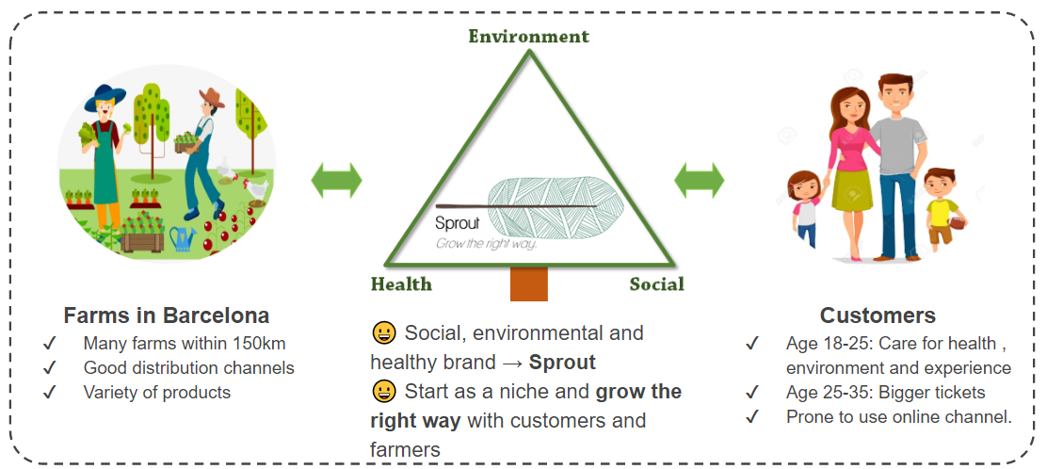

*Figure 1. The green triangle philosophy.*

Sprout literally means “begin to grow or produce new growth” related to plants and environment. This concept is directly connected to the main objective of the company activity which aims to grow in the right direction at the same rythm with all the parts involved in the chain value. Not only the environment, but also people associated with the company - farmers, customers and workers - grow and develop with the company. With respect to the slogan, “Grow the right way”, the company depicts the intention to grow in a social, ecological and environmental way.

Our logo symbolises a tree, which is an obvious association with the company Sprout. Likewise, the tree points to the right direction which is related to the slogan. In other words, this symbol is the environmental message which represents the “right way” people will take when choosing Sprout as their brand.

**Services and Products**

Sprout offers two products: local produce and farm visit experience. Through our app and website, customers will be able to order and customize their own basket of produce, which will then be delivered by us. This is more commonly known as the farm-to-table movement. Our delivery system is weekly instead of on-demand as part of our commitment to reduce pollution. We also commit to using recyclable packaging where possible.

Additionally, we want to go beyond farm-to-table. Our farm partners are selected based on their farming practices. We would only work with farms that practice sustainable farming, use minimal (or no) pesticides, promote ecological balance, and conserve biodiversity. We would like to encourage our farmers and customers about the importance of crop rotation: purchasing and eating whatever is on season instead of only consuming the “cream-of-the-crop”. Dan Barber, a famous US chef, advocates a more expansive farm-to-table movement. He claims that “the farmer ends up bringing to market what he or she knows you will buy. It's not a true representation of the entire farm, it's not a true representation of all the crops that are needed to grow in rotation that enable a farm to be healthy. Soil health, for one thing.”[5]

Our second product - the farm visit experience - attempts to educate more customers about this issue. Through this visit, we would like to show the customers where their food comes from and how they are produced. We would also show the importance of crop rotation and soil health. Instead of just selling the typical produce, we would promote and teach them how to prepare less well-known crops. By creating a demand for these crops, farmers would be able to diversify their farms and continue practicing sustainable farming. At the same time, we hope that customers would be more mindful about their food and consume responsibly.

## B. SWOT analysis, Porter model or similar.

In order to assess the current situation of Sprout as a new company in the organic sector and the competence of the market, SWOT and Porter analysis have been developed.

**SWOT Analysis**

SWOT Analysis allows you to understand what you are doing well and what you are lacking in order to take advantage of opportunities and reduce the risk of failure when the begining company starts operating in the market [6]. The main dimensions are the following:

| **Strengths** | **Weaknesses** |
| --- | --- |
| * **Attractive for farmers**: Provide suggested prices to farmers so they can earn the right fees from their products. * **Provide an experience**: We plan to schedule visits to the farms, so the customers can learn more about the products they consume. * **Eco-friendly**: Make partnerships with farms that use organic or biodynamic farming methods, providing an eco-friendly alternative for customers. * **Subscription model**: Offer subscriptions for customers to obtain discounts in products or shipping costs, access to the farm or receive seasonal products on a weekly basis. | * **Lack of capital**: Initial funds would come from our own investment * **More expensive**: Delivery and services provided could result in higher prices for products. * **Logistics**: Management of inventory and delivery can be an overwhelming process |
| **Opportunities** | **Threats** |
| * **Few Direct competitors:** Since it’s an innovative idea, the market has a lot of opportunity. * **Healthy trend**: Organic food is trending upwards thanks to the inclination towards a healthier lifestyle. * **Environmental awareness**: People are more aware about climate issues. | * **EU Competition**: Similar businesses could appear in other parts of Europe before we can expand our business. * **Perishable food**: Hard to maintain inventory. Whatever is not sold would be wasted. |

From the previous analysis, some actions can be taken crossing these four dimensions which will result in an action plan for Sprout:

* Strengths to leverage opportunities:
  + The eco-friendly model can be used to promote the ecological message of the brand since many people are more aware of environmental issues and healthy lifestyles. They would feel identified with the company mission.
  + Providing an experience will enhance users to become intimate partners with the company and be part of the subscription model trend in order to create loyal and frequent customers since there is a big demand, but not domestic channels to reach those customers.
* Strengths to reduce threats:
  + Working directly with farmers and using Analytics in the business process will allow Sprout to keep a good level of inventory and distribution thereby reducing the risk of perishable food.
  + The experience Sprout transmits as a brand will be a key factor to compete in european market.
* Reduce Weaknesses by Opportunities:
  + The lack of capital can be reduced by investing among the creators of the business idea. Since the business is a trend nowadays, We, as creators, are sure we will get our investment back.
  + Getting more customers and more people interested in the brand would make our delivery cheaper
* Strength a weakness to reduce a threat:
  + Sprout should be aware to have enough capital to compete with other new organic companies in european union
  + Sprout should also improve the delivery services in order to avoid perishable food.

**Porter Analysis**

Porter Analysis is an important business tool to understand if the company has a future in the market, how the company should compete and identify a strategy to be profitable. The analysis consists on the following 5 dimensions which will be explain in detail:

1. Power of Suppliers (Moderate Threat)
   * A lot of organic farms are close to Barcelona; the offer is high.
   * There is a wide variety of ecological fruits and vegetables. Spain has the 40% of all Europe production [7]
   * Farms associated with supermarkets and shops (massive deliveries).
   * Since the production is high (even more than expected), providing the service would be convenient for the farms to have additional revenues.
2. Power of Clients (High Threat)
   * A high number of customers since they are products of basic necessity and the demand for organic products is increasing.
   * The purchase frequency is high, some of those purchases aren’t planned, so they look for convenient stores [8].
   * There are a lot of stores for traditional products close to customers.
   * Time and quality is a key difference.
3. Threat of new entrance (Low Threat)
   * The barriers are really high since they will have to deal with many suppliers.
   * More customers and suppliers will turn into less expenses (high initial investment).
   * The logistics are really complex (deliver the products so that they don’t perish).
4. Threat of substitutes (High Threat)
   * Commonly, supermarkets and shops (they are more convenient).
   * The price tends to be cheaper, but the quality is not the best.
5. Competitive Rivalry (Low Threat)
   * There are only few competitors in the sector of organic food
   * The opportunity to get loyal customers is high

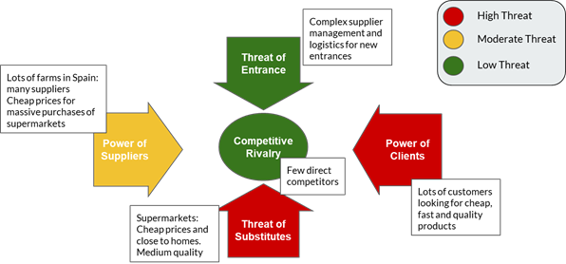

*Figure 2. Porter Analysis.*

In conclusion, the spanish market is really promising for Sprout according to the Porter analysis. Although the power of clients and substitutes is high, Sprout can take advantage of the lack of competitors in order to get customers engaged with its innovative business idea and start to create a niche of loyal clients. Moreover, with the high threat of entrance, Sprout can control the major part of the organic market share for a long time.

## C. Competitive advantages.

The main competitive advantages of Sprout are focused on the fact that we not only offer a product, but also we offer the experience of being part of Sprout’s family and connecting with the environment, the production process of the organic food and the farmers. The most innovative ideas we are offering are the following:

1. **An integrated platform** to connect organic farms and customers. Sprout is providing an application for both users and farmers so that they can have the comprehensive experience of consuming organic food.
2. **Subscription System** - People can subscribe to get produce weekly or fortnightly. This feature allows customers to become frequent or premium users of the service. It will change the traditional system of e-commerce and it will allow Sprout to save expenses on logistics since it promotes more planification.
3. **Open-day** - Customers can have interesting experiences in the farms at the weekend. These experiences represent a connection with the farms which haven’t been done by other competitors. Sprout has the objective that customers can know how their products are prepared and they can be more aware of the environment.
4. **Working with local farmers -** Sprout aims to support local farming, self sustainability and reducing the carbon footprint which is part of the strategic plan to engage both customers and farmers and increase profitability.
5. **Smart recommendation** system for suggesting price and discount, taking into account demand and seasonality. Applying Analytics is so important these days to generate additional value in business; thus, Sprout is going to focus on maximizing profits for both the company and the farmers using data ethically.

## D. Mission and basic strategic approach of the company, viability conclusions

One of the United Nations’ Sustainable Development Goals is “Zero Hunger”. It aims to “end hunger, achieve food security and improved nutrition, and promote sustainable agriculture.” [9] One of the ways to help is by “supporting local farmers or markets and making sustainable food choices”. It is with this in mind that we decided to create Sprout.

Sprout was founded based on the idea of social change. Our vision is to “transform how we grow, share, and consume our food.” Specifically, we want to empower local farmers and connect them to consumers. The benefits are enormous: local farmers benefit from having more customers, the customers benefit from having fresh vegetables, and we minimize our carbon footprint through shorter transportation routes (instead of having to import from elsewhere). As a reminder of our vision, we have adopted the tagline “Grow the right way”.

As a company, one of our key values is fairness. This applies to all aspects of the company: fair compensation to the employees and fair price to both our farmers and our customers. We strive to compensate the farmers fairly and - at the same time - provide a reasonable price to our customers. Indeed, our mission is “to create a mutually beneficial relationship between local farmers, customers, and the environment through fair exchange and shared farm experience.”

# 

# 2. Market research and analysis

## A. Potential customers (segments and volume)

### 1. Qualitative Research

In order to identify the potential customers, we conducted a preliminary qualitative research. This is split into two parts: one is about the potential customers, and another is about the headquarter of the company. From this research, we want to formulate hypotheses which will later be tested through quantitative research. Specifically, we want to generate hypotheses about:

1. The demographics of our potential customers (age, gender, income level)
2. The general interest about locally-grown organic product
3. The headquarter of our operation

We decided early on to choose Spain as our starting country due to practical reasons: all the co-founders currently live in Spain so it will be easier to start our company here. However, we need to do research about which city in Spain is the most suitable for our product. Based on our findings, we chose Barcelona due to the following reasons:

1. Catalonia is one of the richest provinces in Spain, contributing to 20% of Spain’s GDP [10]. This translates into strong purchasing power. Barcelona, the capital city of Catalonia, would be a good starting place.
2. Catalonia has the third-largest organic farming area in Spain [11]. The abundance of farms means that it will be feasible to connect local farms to consumers.

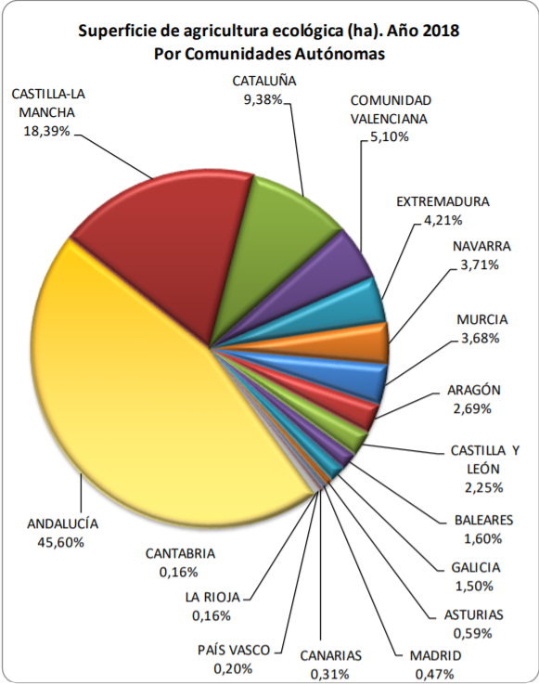

*Figure 3. Organic Farming Area in Spain by Provinces*

Since we have to take logistics into account, we will work with farms only within 150km radius of Barcelona.

From our literature review, we also discovered that the main customers for organic products are usually within the 18-25 and 26-35 age groups [12]. This will be our hypothesis for quantitative research.

### 2. Quantitative Research

We conducted quantitative research in the form of a survey. The main points we want to obtain from this survey are:

1. Customers’ shopping habit
2. Their general interest in consuming organic food
3. Their interest in visiting farms.

Unfortunately, we could only do an online survey due to the lockdown imposed by the Spanish government. Nevertheless, we managed to receive 75 responses and the key findings are:

1. Shopping Habit:

* 85% get their groceries from supermarkets, but 70% would consider buying online.
* 59% buys groceries once a week
* Respondents use more recyclable materials (4.2/5)

1. Organic Food:

* Respondents are less likely to go out of their way to get organic food, but they will consume more if they are more available (3.9/5)

1. Interest in Farm Visit:

* Female 21-25 age group (7.2/10)
* Female 26-30 age group (7.6/10)

The results are quite in-line with what we predicted and aimed to do. We wanted to only do a weekly delivery to save cost and also reduce carbon footprint from delivery. We also received good responses about the farm visit.

Additionally, we also contacted several farmers around Barcelona. We enquired about their current situation of reaching the customers. Some of them did not have a proper system to deliver to Barcelona even though they were only 50km away, while others are working to deliver their products to the supermarkets. Based on this, we believe that there is an opportunity for us to connect them directly to the customers and take care of the logistics for them. They were also quite open about the possibility of arranging a farm visit.

## B. Market size and tendencies (consumers’ expected behaviour)

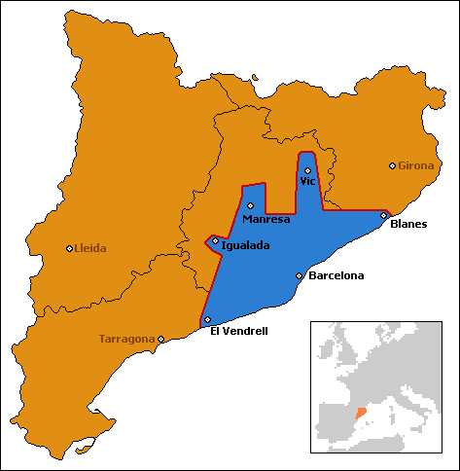

*Figure 4. Barcelona urban area*

Our product is closely tied to the location of the farmers and our customers. As such, in this initial stage we will focus only on Barcelona. The Barcelona urban area has ~5 million people, of which around 20% are within our target age group. This would give us around 2 million people as our potential market size.

Our survey shows that people are eager to consume more organic products if they are more readily available, so we are confident that our business will take off and we will increase our market share in the subsequent years.

For the farmers, we expect to sign around 20 farms by the end of first-year to have more supply and more variety for the customers.

## C. Existing competitors (lessons learned)

From our research, we discovered some competitors that offer similar services. They are Organic Basket Barcelona, El Broquil, and Agroboca.

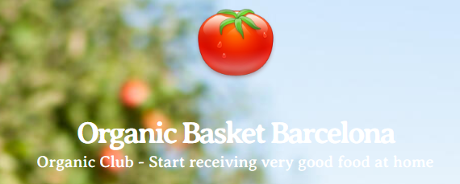

Organic Basket Barcelona sells baskets of vegetables and has a 4-week commitment. They work with local farms and only offer seasonal products. Baskets are delivered on a weekly basis.

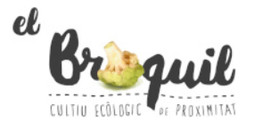

Similar to Organic Basket, El Broquil also offers a weekly basket to customers. However, this company also allows customers to purchase vegetables per unit instead of buying one big basket.



Agroboca is the most similar to our business model, in the sense that it is a marketplace - farms can sign up to be included on their website. They offer 24-hour delivery service, and customers can also specify which farms they want their food to come from.

Based on these competitors, we realise that we have some differentiating features which will distinguish our service to our competitors, mainly:

1. Subscription service

We offer subscription service for our customers. These “VIP users” will enjoy benefits such as reduced price on our farm visit (10% of discount). VIP users will also be prioritised in terms of product selection.

1. Farm visit

We aim to be more than just a marketplace; we want to create connections between the products, the farmers, and the customers. By strengthening this bond, customers will be more attached to our company and we increase the loyalty of these customers.

## D. Sales Prediction and market share

To predict the number of sales, we follow a commonly-used launch prediction used by startup companies where we expect a high initial growth which will then flatten over time.

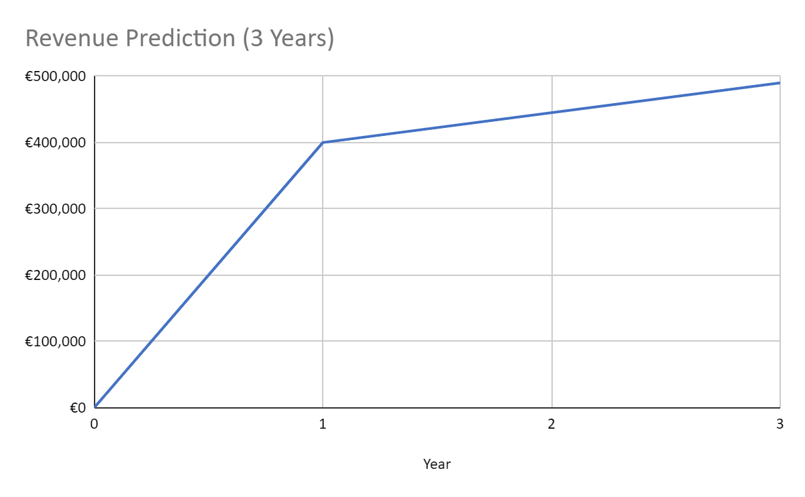

*Figure 5. Predicted Revenue (3 Years)*

# 

# 3. Marketing Plan

## A. General Marketing Strategy (segmentation, targeting and positioning)

As mentioned, our target market for customers are people in Barcelona between the 18 - 35 age group. As such, we will mainly use online advertisements and social-media related marketing to promote our company. We will use Facebook, Instagram, Meetup, and employ influencers via Youtube videos. Offline, we will attempt to invite communities to join our farm visit and spread word-of-mouth to other members.

As for the farms, we will reach out one-by-one to invite them to our platform.

## B. Price policy (P2)

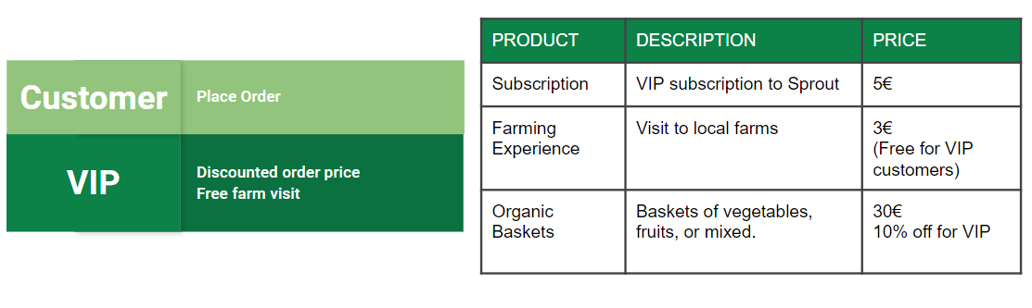

We employ two different pricing strategies: commission-based and subscription-based. For commission-based, we earn 25% of commission for each basket sold on the platform. This is paid by the farmers to us. The price for each basket depends on the size of the baskets (from 5kg to 10kg).

We also offer subscriptions to our customers. The perks include special discounts on the baskets and free visit to the farms. This will be available for 5€ monthly.

Additionally, we will also organise farm visits (initially once a month). This will be free for the VIP users but anyone can join by paying the transport fee. There, they will get the opportunity to be a part of the farming process and gain knowledge from the farmers. The price would approximately be 30€ excluding the delivery fee depending on the distance to the farm.

## C. Organization of sales and distribution (P3)

Our main channel of communication would be online. To that end, we will build a website where users can sign-up and order their products. We will also create a mobile app for Android and iOS users. Products will be delivered weekly to the customers.

In addition, customers will also be able to buy their products during the farm visits. The visits can be arranged through our online platforms as well.

On the farmers side, there will be a sign-up option on our website if they want to join our marketplace. Another option would be to be approached by our Sales Team.

## D. Product, Service and guarantees policies (P1)

Sprout guarantees that our products and services are:

* Fresh, locally-sourced product

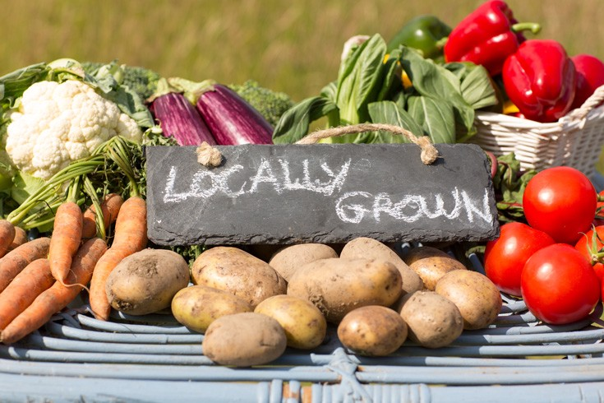

We only work with farms that employ sustainable farming practice, use harmless fertiliser, and use no pesticide. This ensures the freshness and the quality of the products.

* Sustainable packaging and minimal carbon footprint

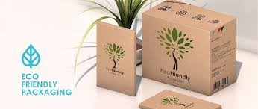

Wherever we can, we will use sustainable packaging to deliver your products. We will also ensure that the delivery route is the shortest path to reduce the carbon footprints of delivering your product.

* Personalised recommendation

Your feedback and opinion is very important to us. Any feedback you give us will help us get to know your preference better and we will strive to give you the best option that we have.

* Customer service



We will be available 24/7 to listen to your feedback and suggestion

* Secure payment



We will ensure that payment on our platform is completely secure and will notify you immediately if there are any abnormal transactions.

* Privacy



We are committed to ensure that your data remains private and secure. We will comply with GDPR rules and be completely transparent in why and how we use your data.

## E. Advertising and promotion (P4)

We will have two different strategies for promotion, one for the end-users (customers), and another for the farmers.

### 1. Customers

We want to focus on online advertising, and our target market is suitable for this type of advertising. According to vincos.it - a company in social media analytics - Facebook is the most popular social media in Spain as shown below [13]. The second most popular social media in Spain is Twitter.

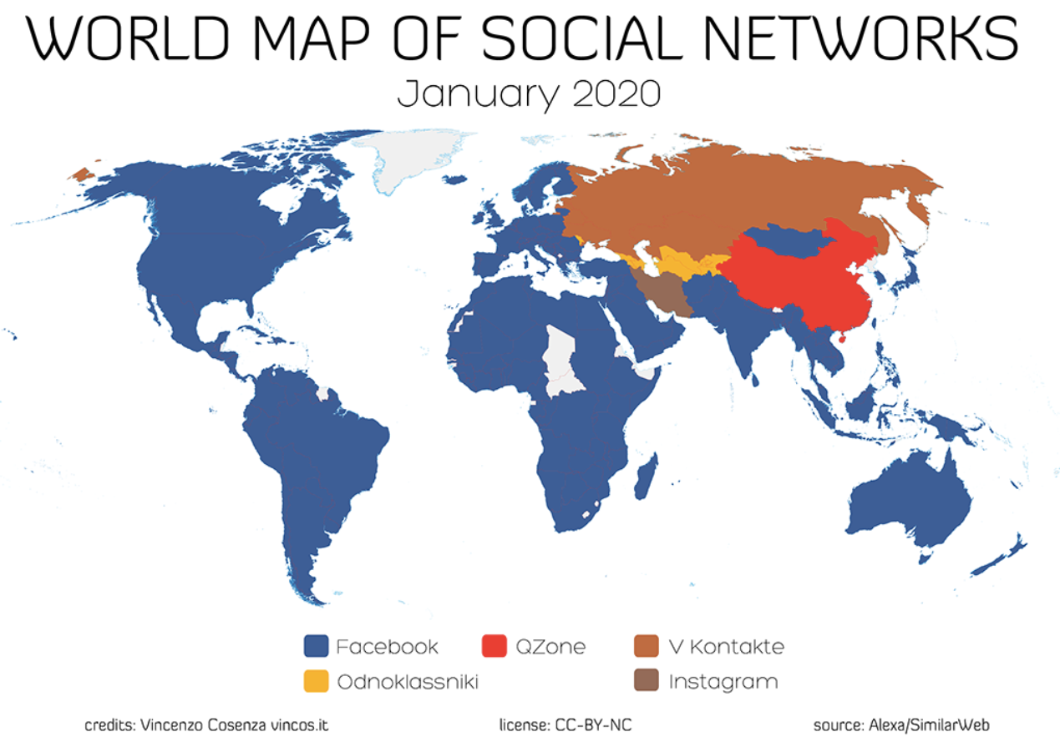

*Figure 6. The Most Popular Social Media*

This being the case, we will focus on several social media platforms to advertise:

1. Facebook
2. Twitter
3. Instagram

In addition, we will employ influencers to help promote our app. This will be done by hiring them for the farm visit. In return, they will create a vlog - usually on Youtube - detailing the farm experience which will attract more users to join the visit. This strategy works really well for the company in which one of our co-founders worked in.

Last but not least, we will also advertise our farm visit on Meetup as part of an eco-tourism experience. Advertising on Meetup is inexpensive and may help spread word-of-mouth about not just the visit, but also our platform and we may be able to convert some visitors into customers.

### 2. Farmers

We will regularly arrange discussions with the farmers regarding the promotions that we can do together with them. They will earn less profit but this may be covered by more volume.

# 4. Design plans of the new products / services to develop and Operations Plan

## A. Situation of the design of the product / service, expected problems.

We are offering an online platform for selling and buying organic products. Our platform will be available as a mobile application on both IOS and Android environments. These are some functionalities that will be implemented in our application:

* **Signup**: Farmers and buyers can register a new account
* **Sign-in**: In order to save orders and other information
* **Listing**: Farmers can list their available products with prices
* **Order**: to place an order and track the order

There are some potential problems related to the developing environment (IOS/Android). We can use hybrid programming language to tackle those problems and also save more time to speed up to the production phase.

The list of ordered products will be sent to our partner farms and when they are ready they will be packaged with environment-friendly bags or boxes. Our hired drivers will take care of this. On the app, we are also offering farming experiences/farm visits to our customers who want to see the products that they are buying and have some great moments being farmers.

## B. New future designs.

Sprout will be developed on the cloud using Amazon Web Services to take advantage of their cloud services including: Auto-scaling service, Email Service, etc,. In the backend, we also use some Big Data technologies to handle a large amount of products and sales data. Furthermore, that data can be an excellent source to create a recommendation system which suggests the right product to the right customer at the right time. This recommender can also give suggestions of which crops should be grown according to the product sales to our partner farms.

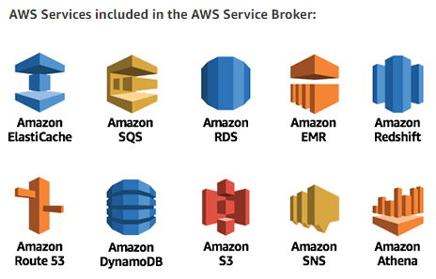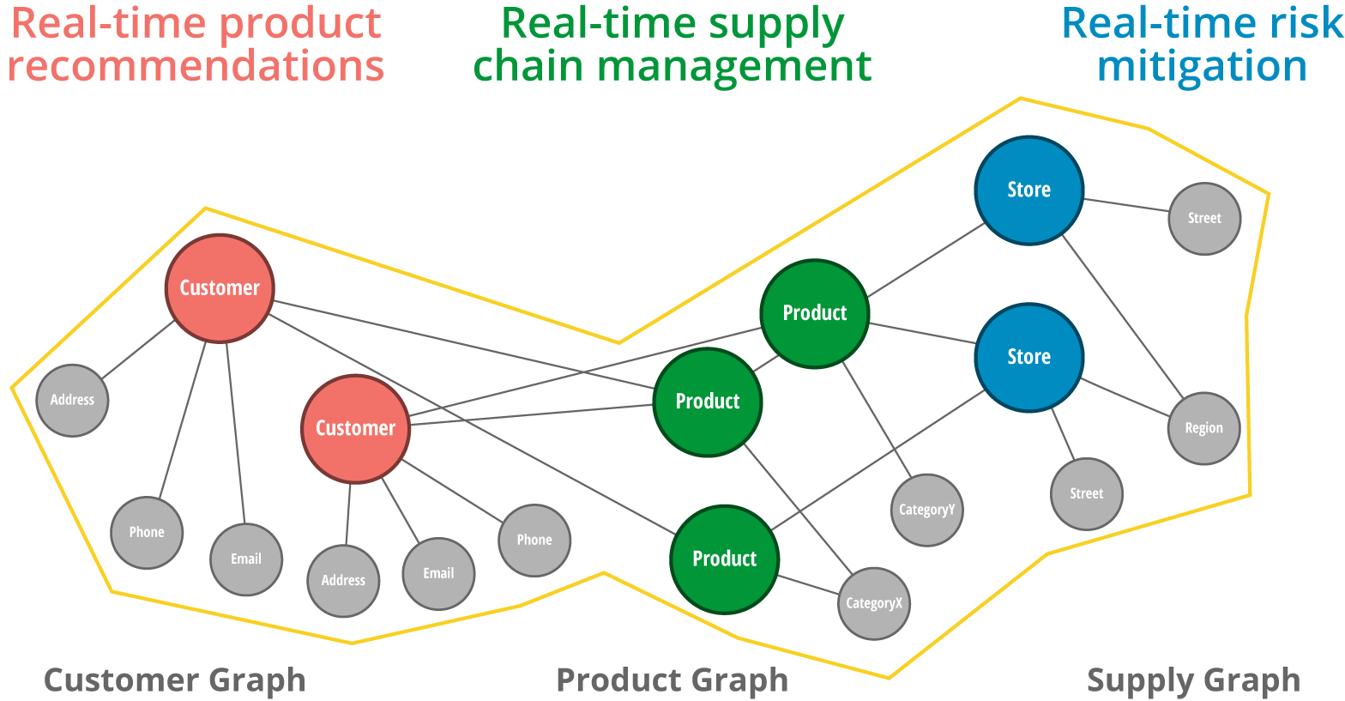

*Figure 7. Future design with a warehouse*

In the future, we can consider having a warehouse so we can start stocking some popular products. The price for these products should be lower since we are buying them with high quantity.

## 

*Figure 8. Future design with a warehouse*

## C. Development budget per product or service line

We are not stocking products and the products listed on our application are grown by our partner farms. The budget for the products depends on the farms and market needs. We spend 1000 Euros to develop our Sprout application. The fee does not include maintenance fee, which means if we want to change or maintain our application we need to pay more depending on what we want. We also need to pay 200 euros for cloud services (AWS) annually.

## D. Geographical location of the productive activities or the service logistics

Our partner farms are the ones located within 150km radius of Barcelona. Productive activities happen in these farms and the products will be delivered to customers based on their orders. Sprout will first expand to other cities in Spain and later to other countries. We need to conduct research about location, market, farms, etc, before choosing our next destination.

## E. Necessary installations, detailed description and technical features

Sprout will be available on App Store (IOS) and Google Play (Android). Farmers and buyers need to install our application on their mobile in order to manage products and orders. Some tutorials of how to use the app will be shown to new users when they first launch the app. Partner farms are required to have some staff trained for the farming experiences.

## F. Production strategy (self-production, outsourcing, etc.)

**Sprout application** will be outsourcing with a budget of 1000 euros. The requirements will be sent by us to the development team. The application should have an ability to scale-up as our business grows. It is hosted on a cloud platform which has almost everything needed for a startup.

**Organic products** are produced by our partner farms. They can freely choose what crops to grow, which also depends on the seasons. Sprout can give them some recommendations of what kind of products are essential to our market so we can both benefit from that and the ultimate goal is to increase the amount of sales. Products will be packaged and delivered by Sprout to buyers based on the orders that they have placed on our application. Sprout does not have a warehouse, we send products directly from the farms to the buyers. Our delivery service will be carried out by hired drivers with their trucks.

## G. Prototype

There are 5 main components on our Sprout application shown as follows.

* **Welcome page**: Let users choose the location to deliver (Figure 9)
* **Menu panel**: Navigate between categories of products (Figure 10)
* **Home page**: Show all products with their prices (Figure 11)
* **Product page**: Show details of a specific product (Figure 12)
* **Checkout page**: Checkout and proceed to delivery (Figure 13)

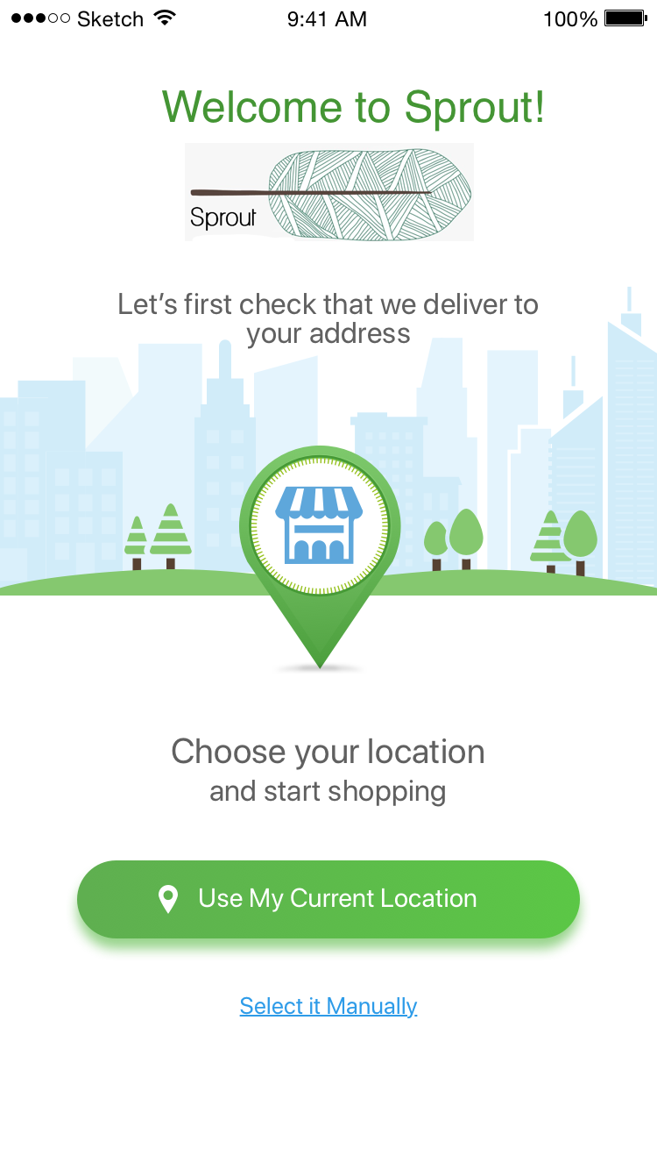

*Figure 9. Welcome page*

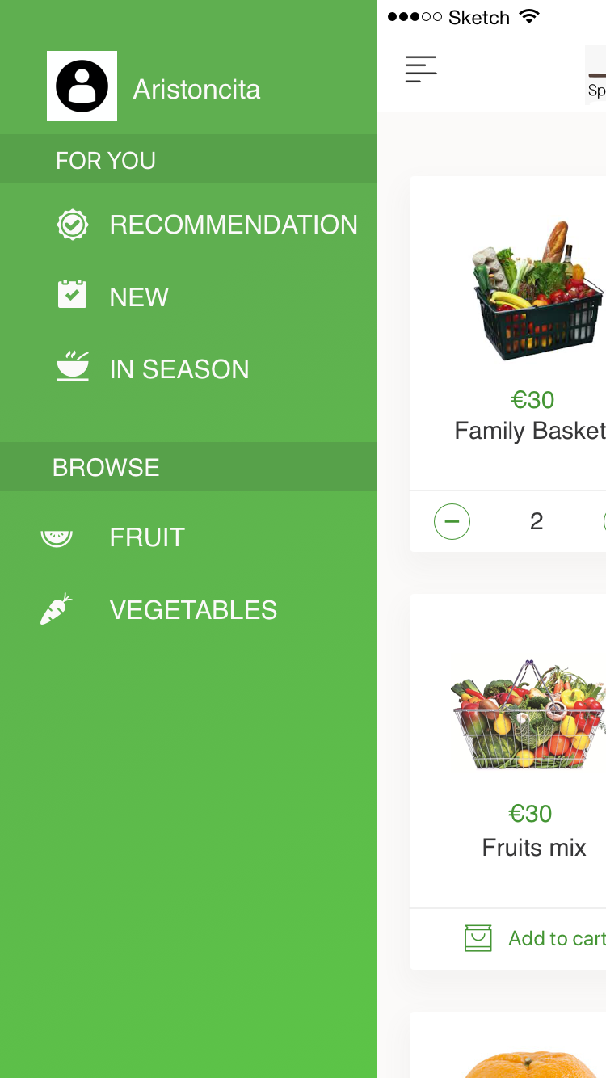

*Figure 10. Menu panel*

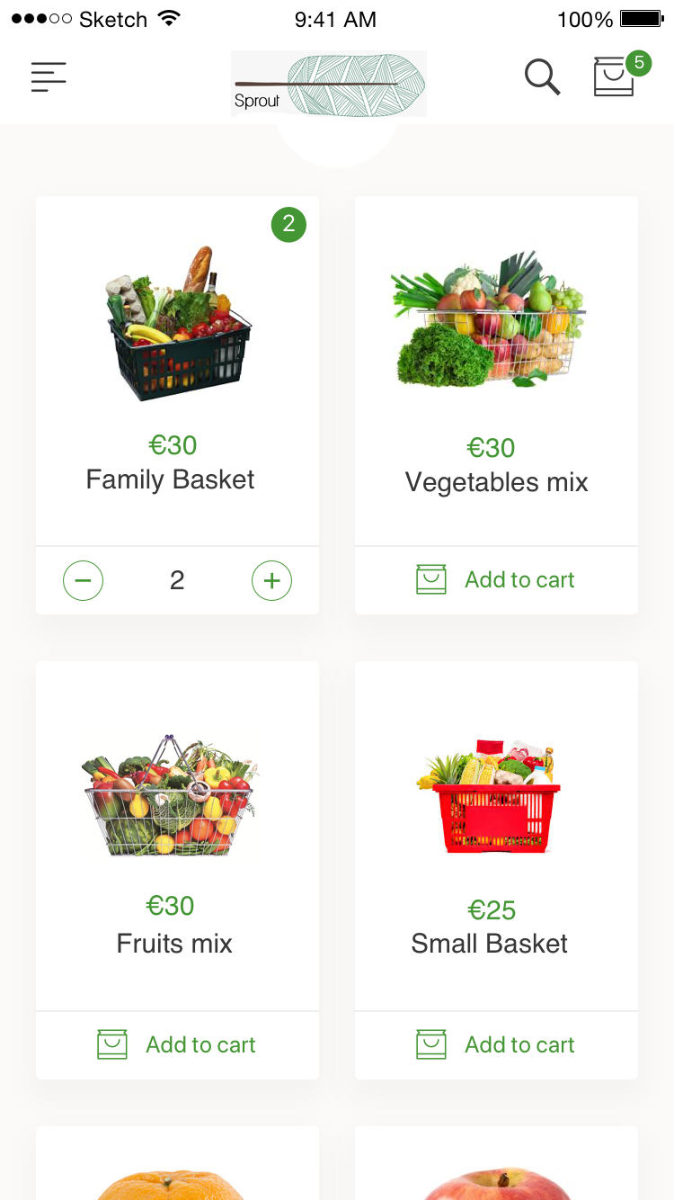

*Figure 11. Homepage*

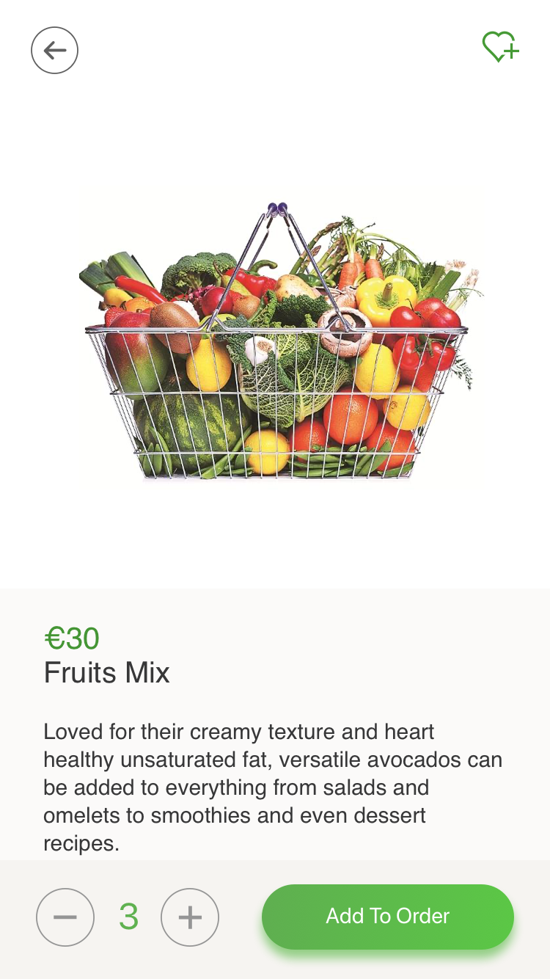

*Figure 12. Product details*

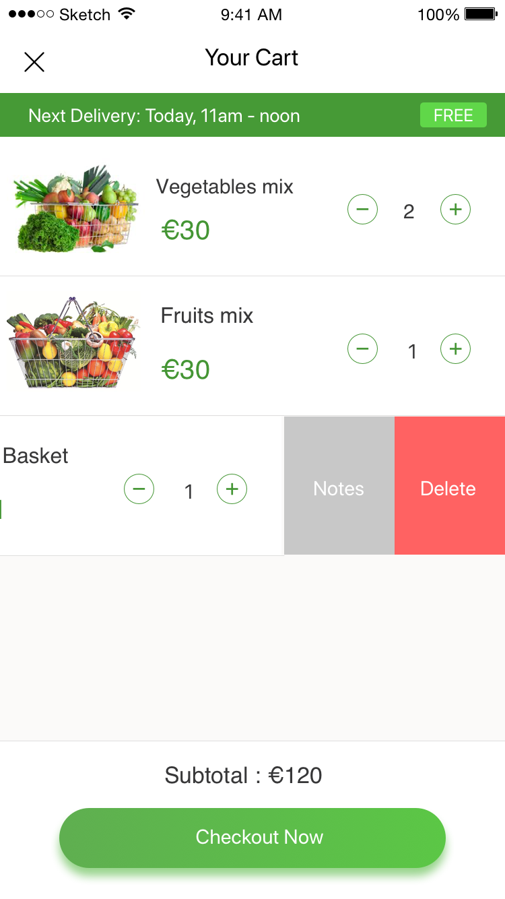

*Figure 13. Checkout page*

# 5. Management Team and staff structure

## A. Organization and people, organization chart and profiles.

The following chart shows the organizational chart of Sprout. The orange section are the ones that we have right now, while the green boxes represent the planned expansion of the company.

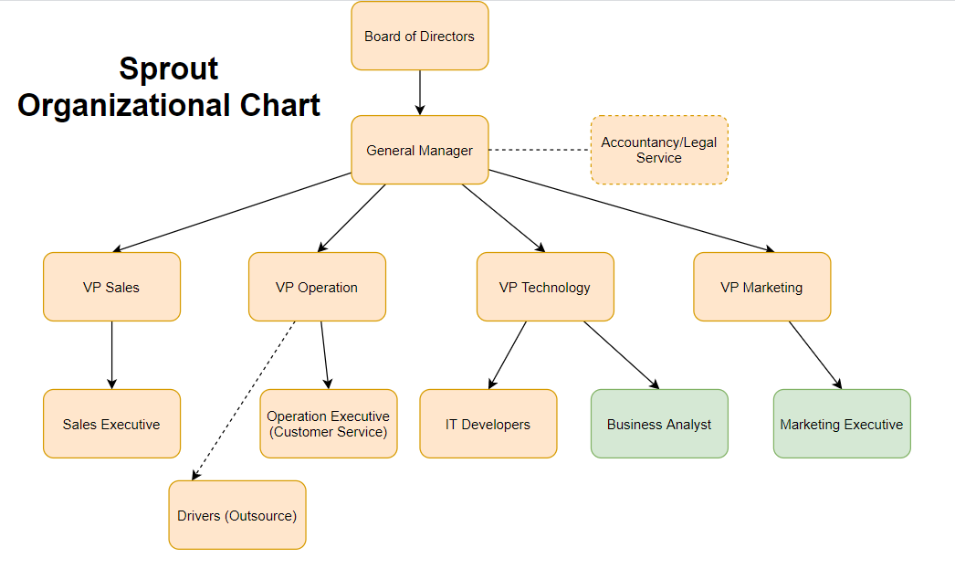

*Figure 13. Sprout Organizational Chart*

## B. Key directors, profiles and individual CV.

Below are the CVs of the co-founders:

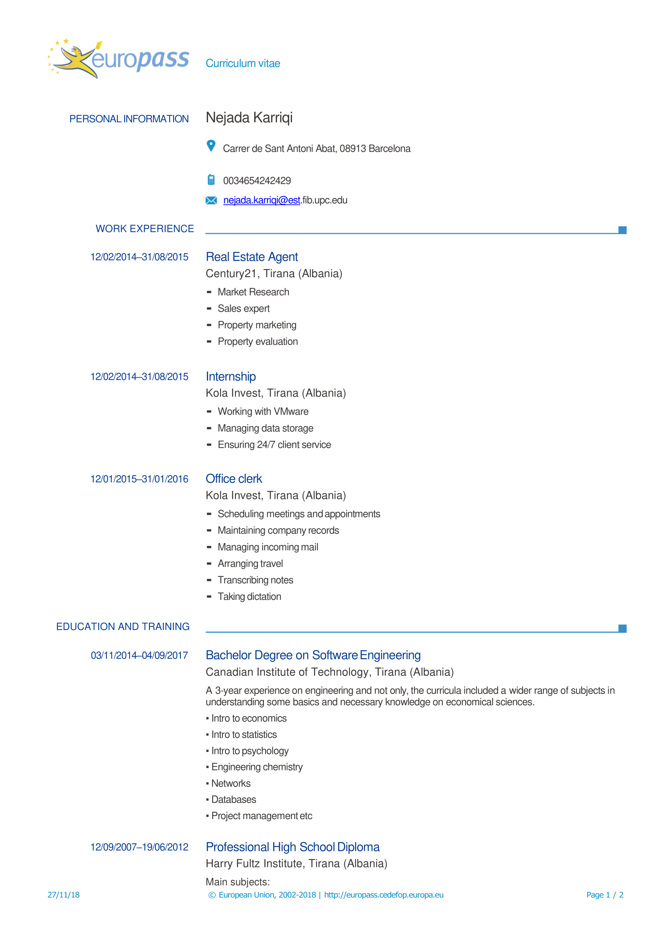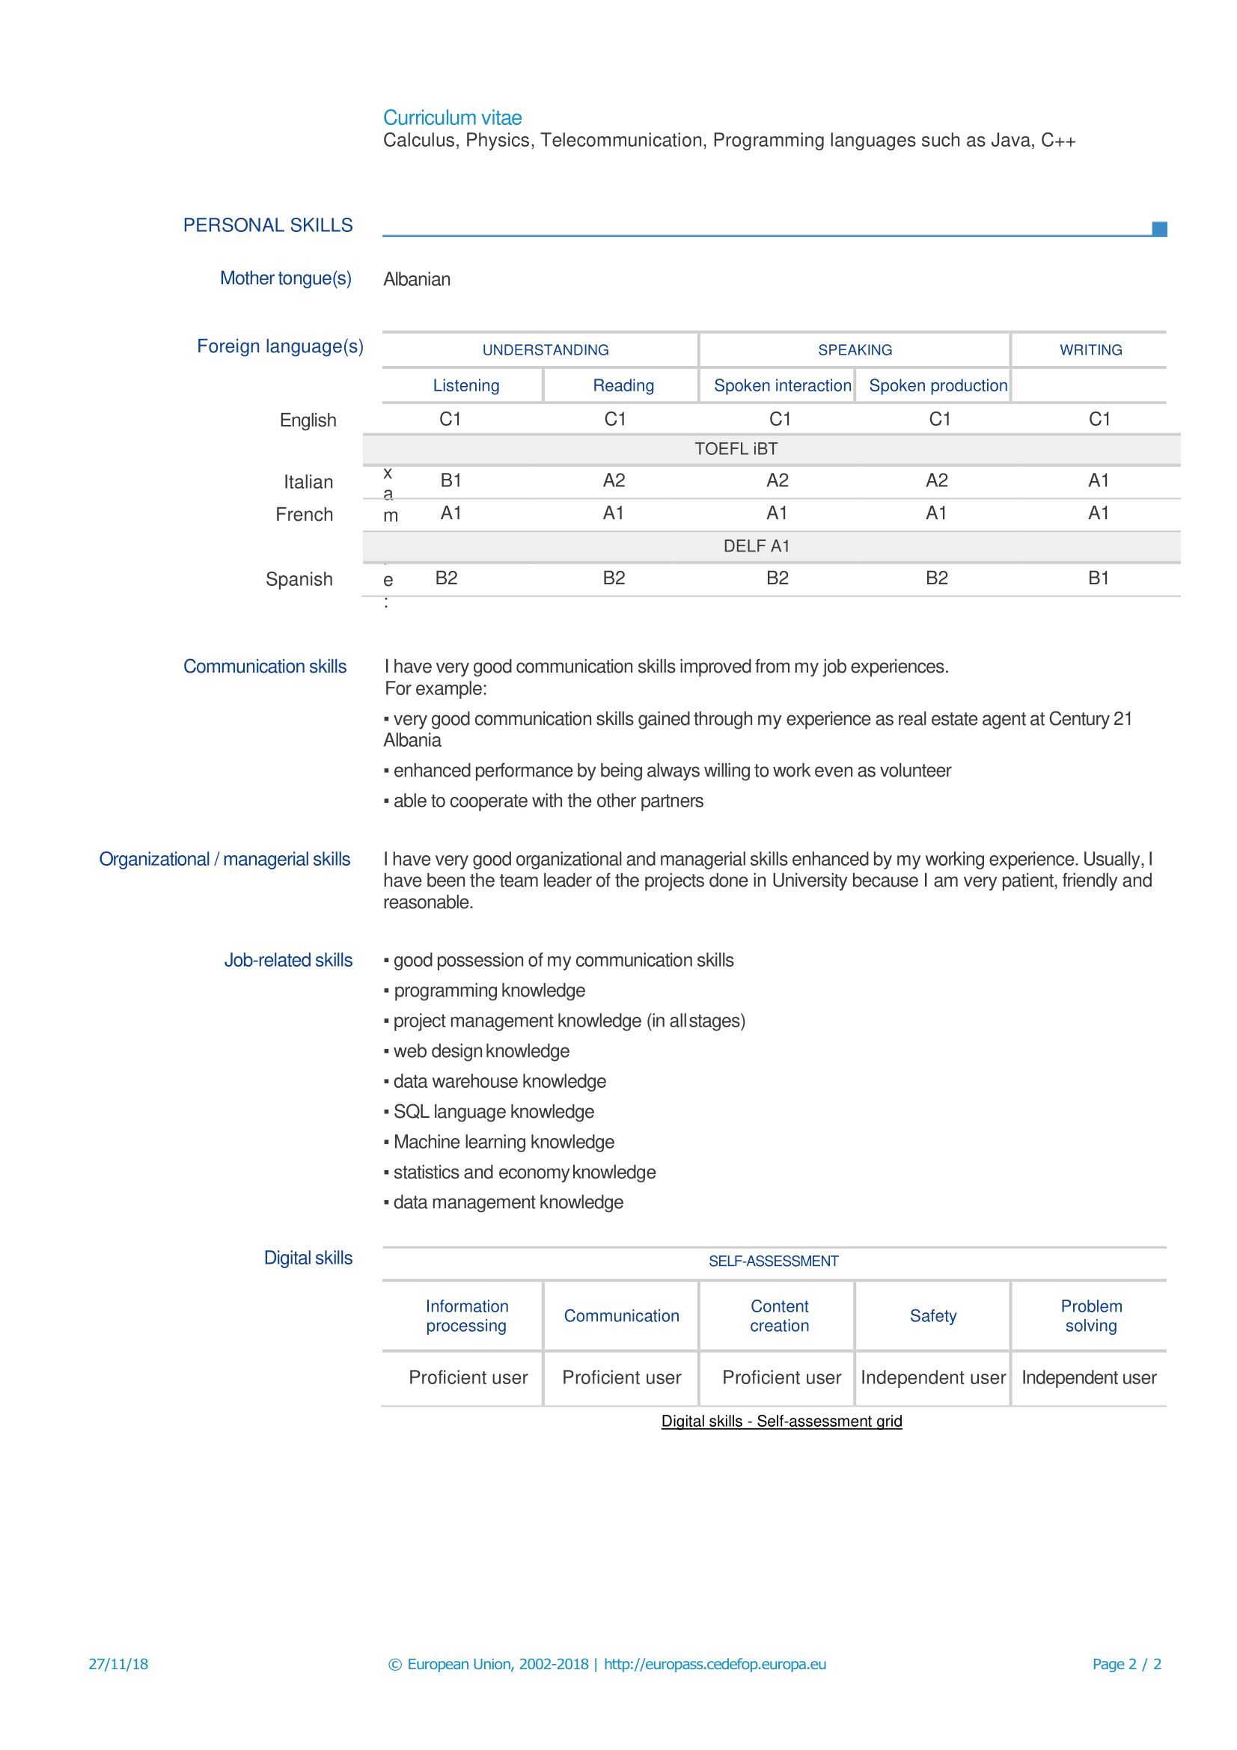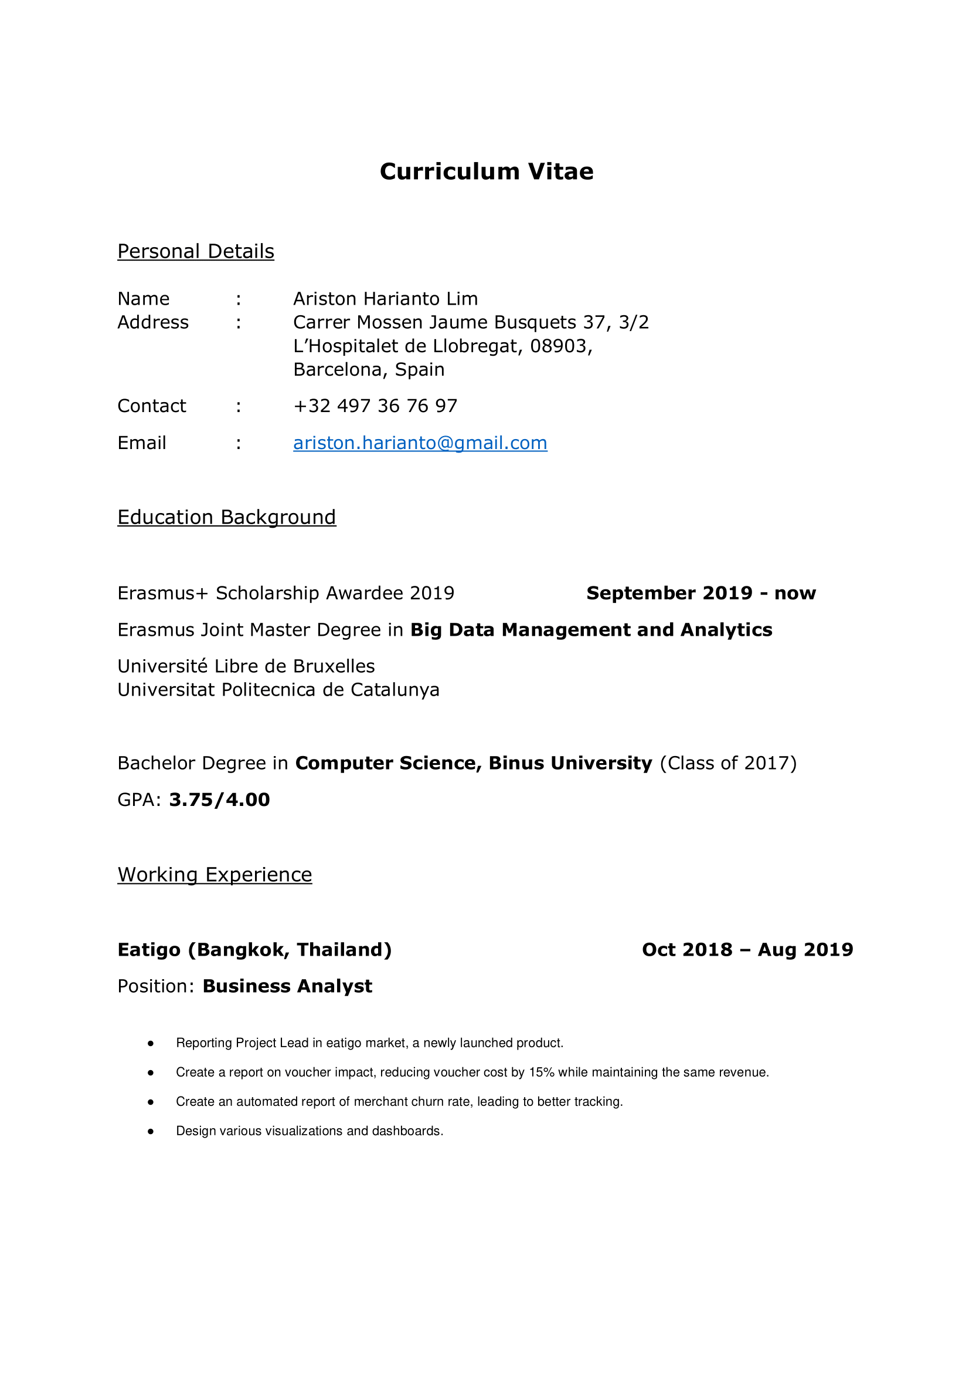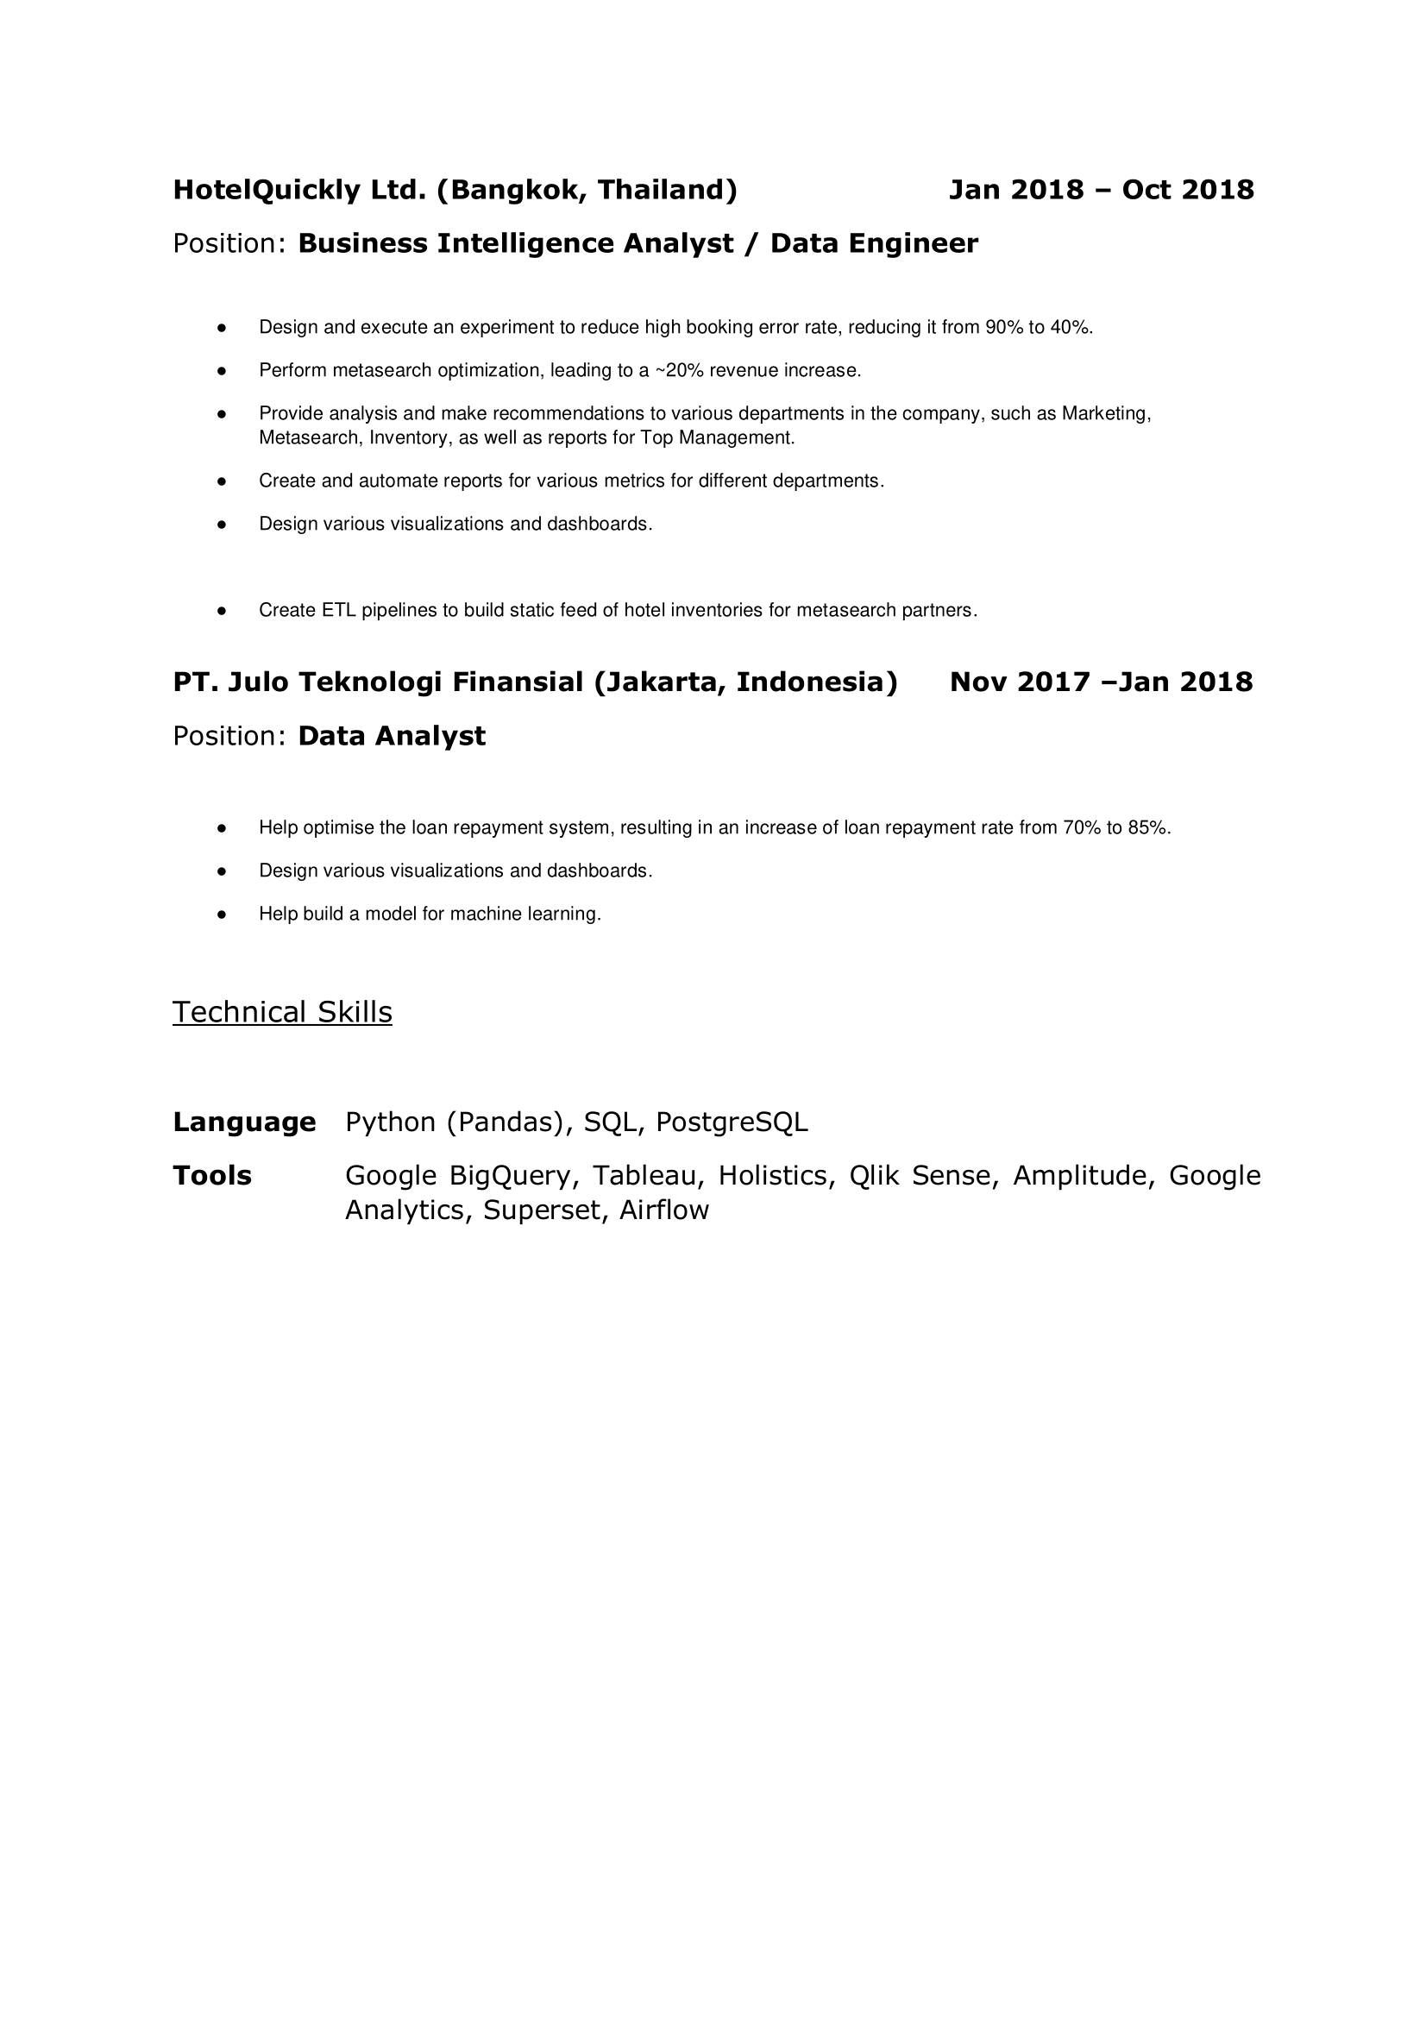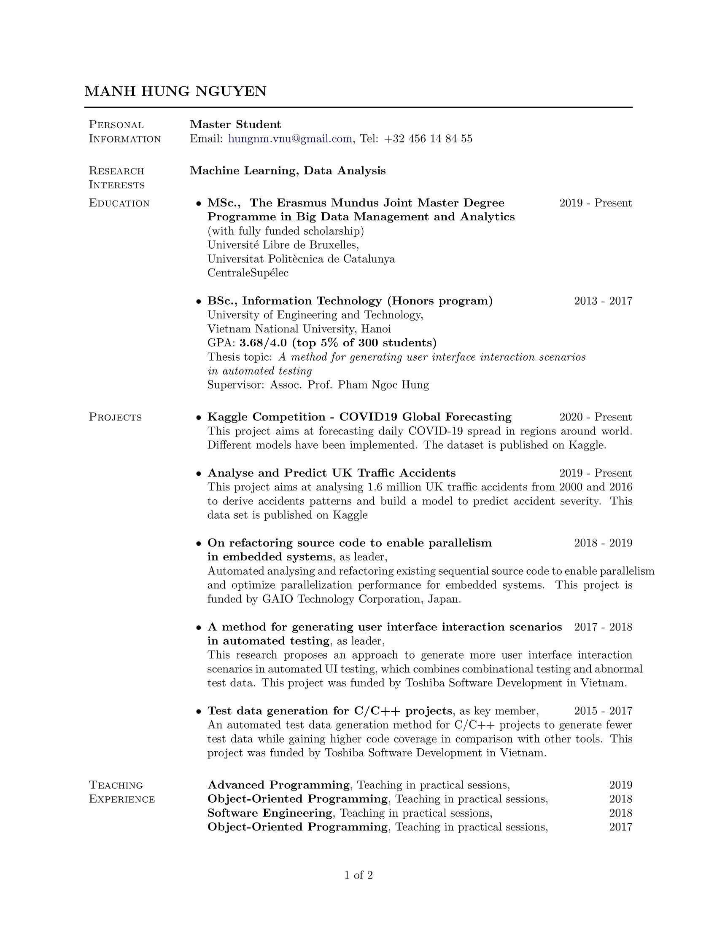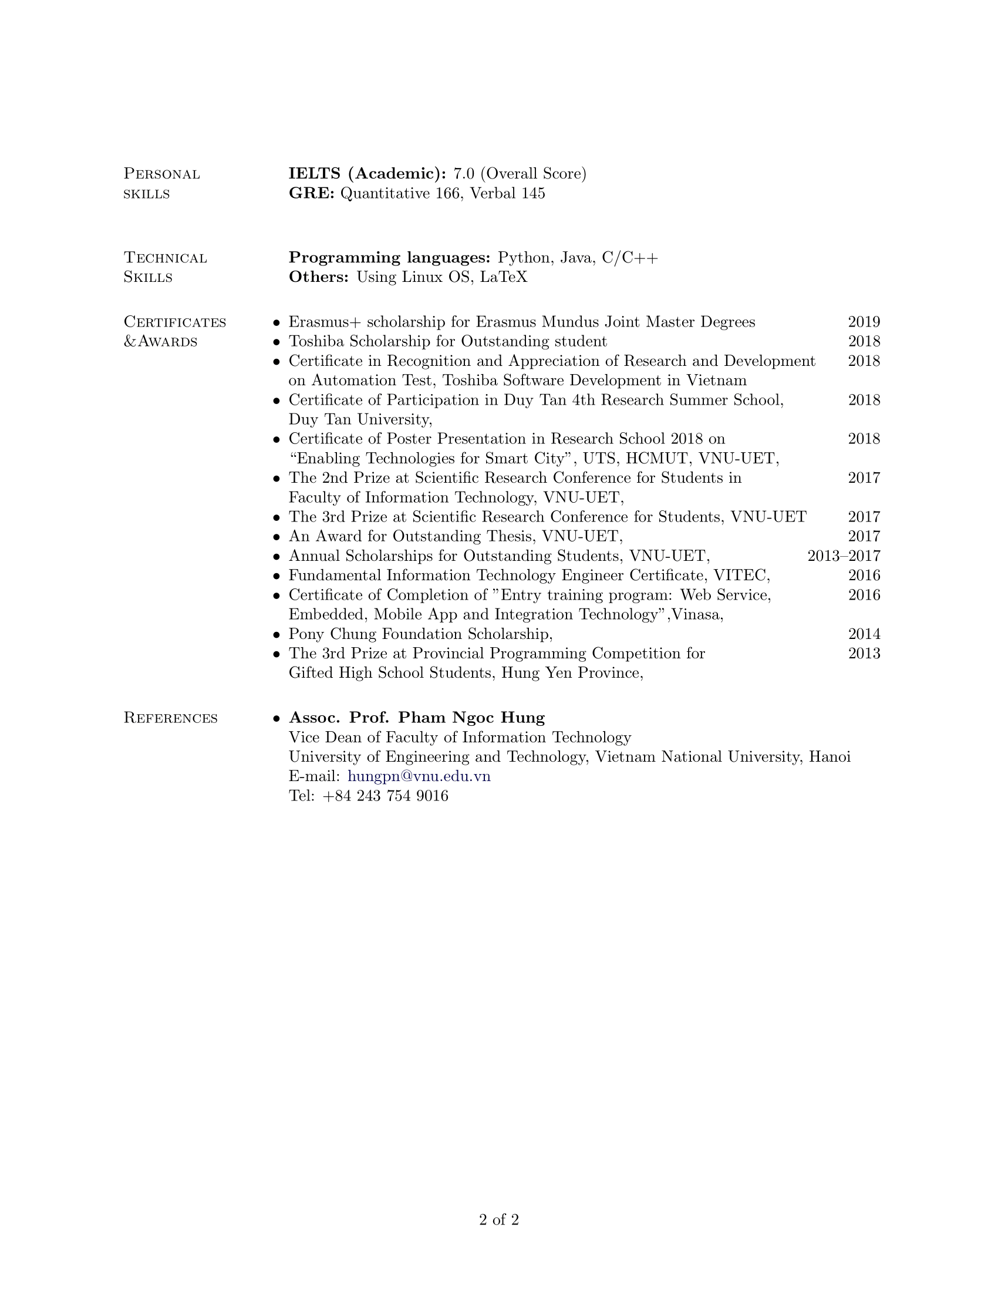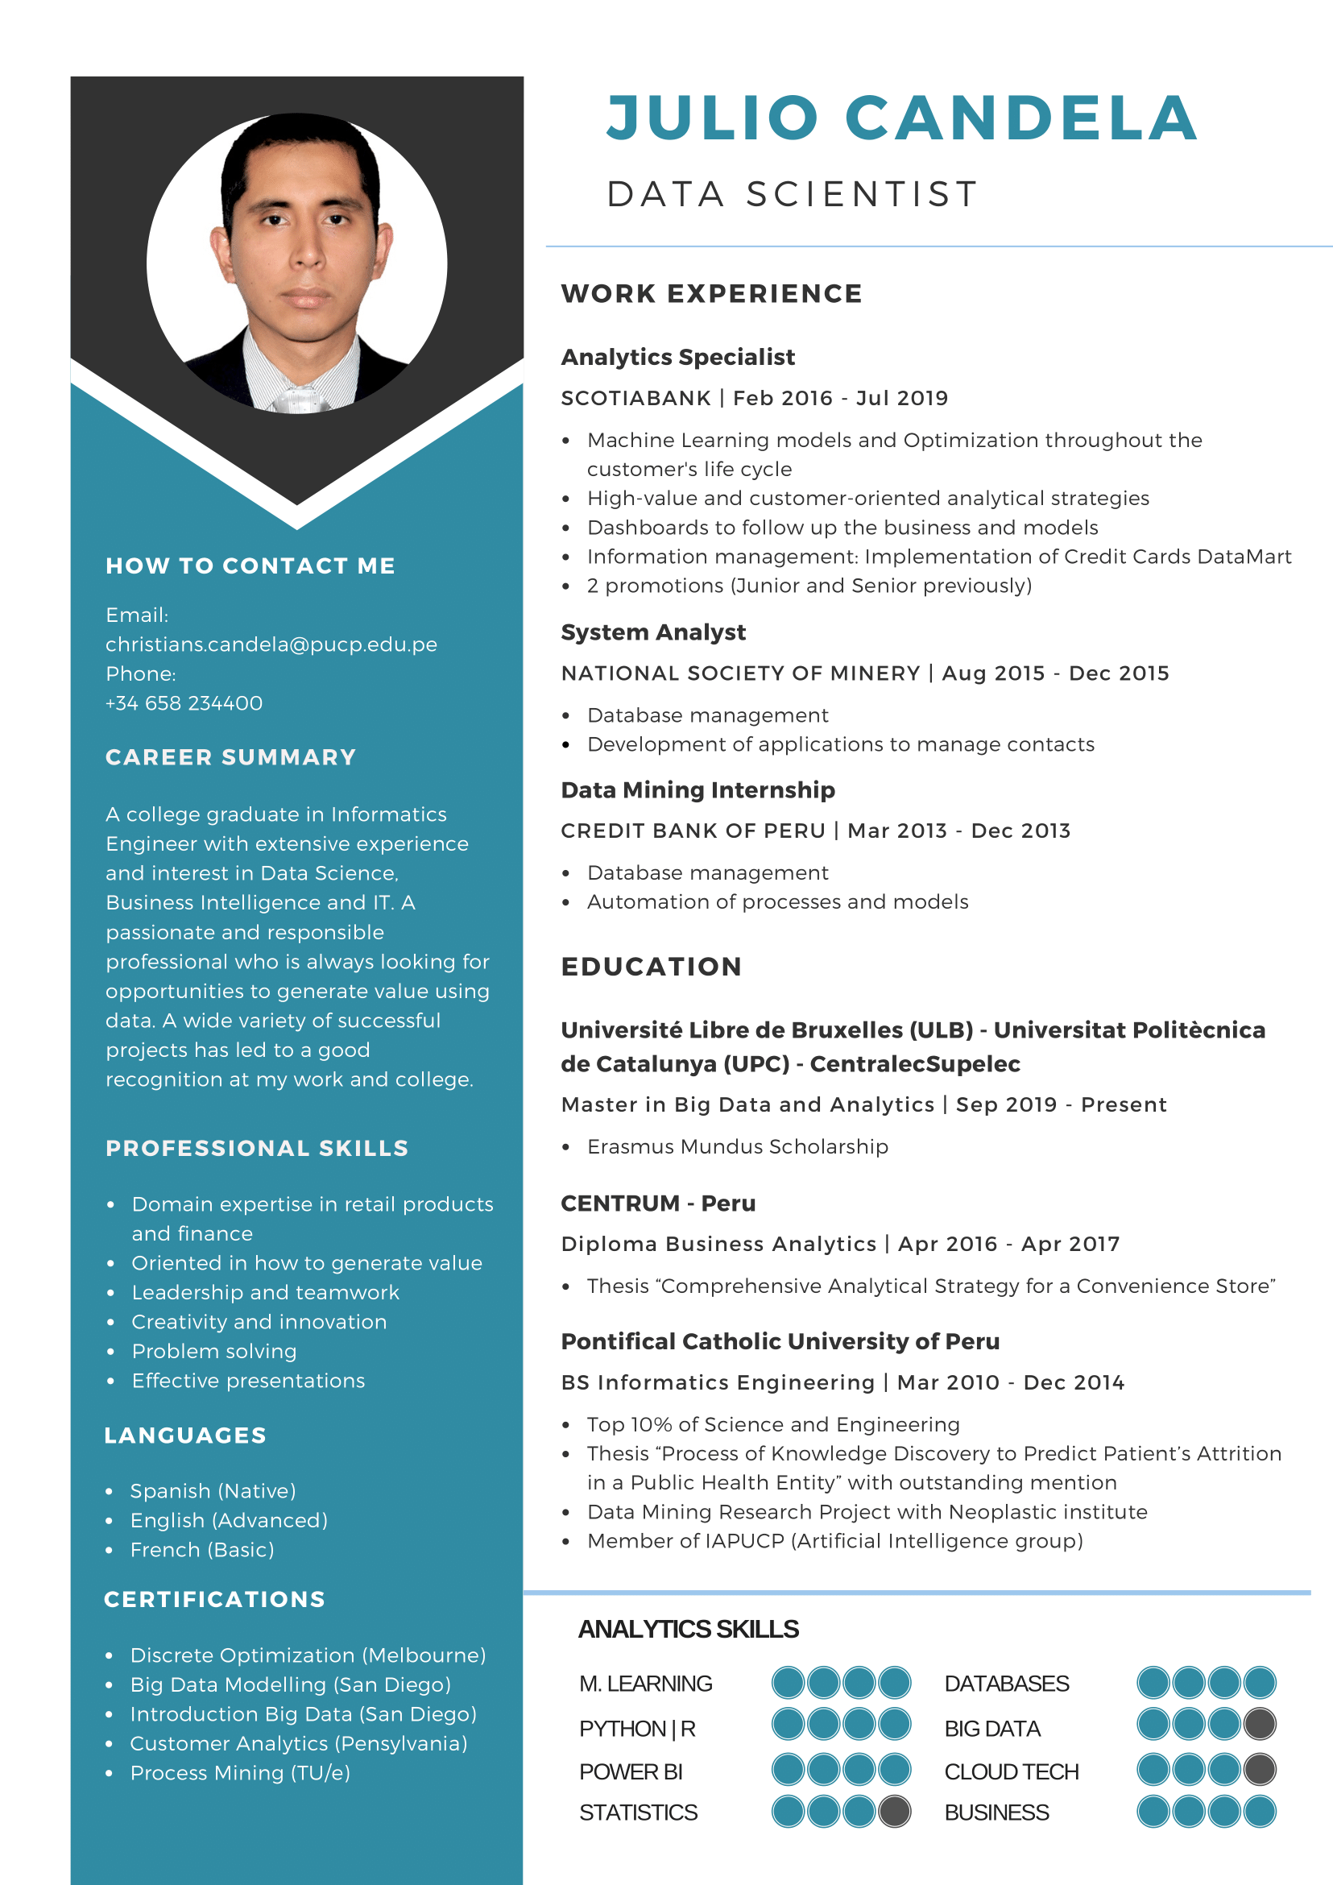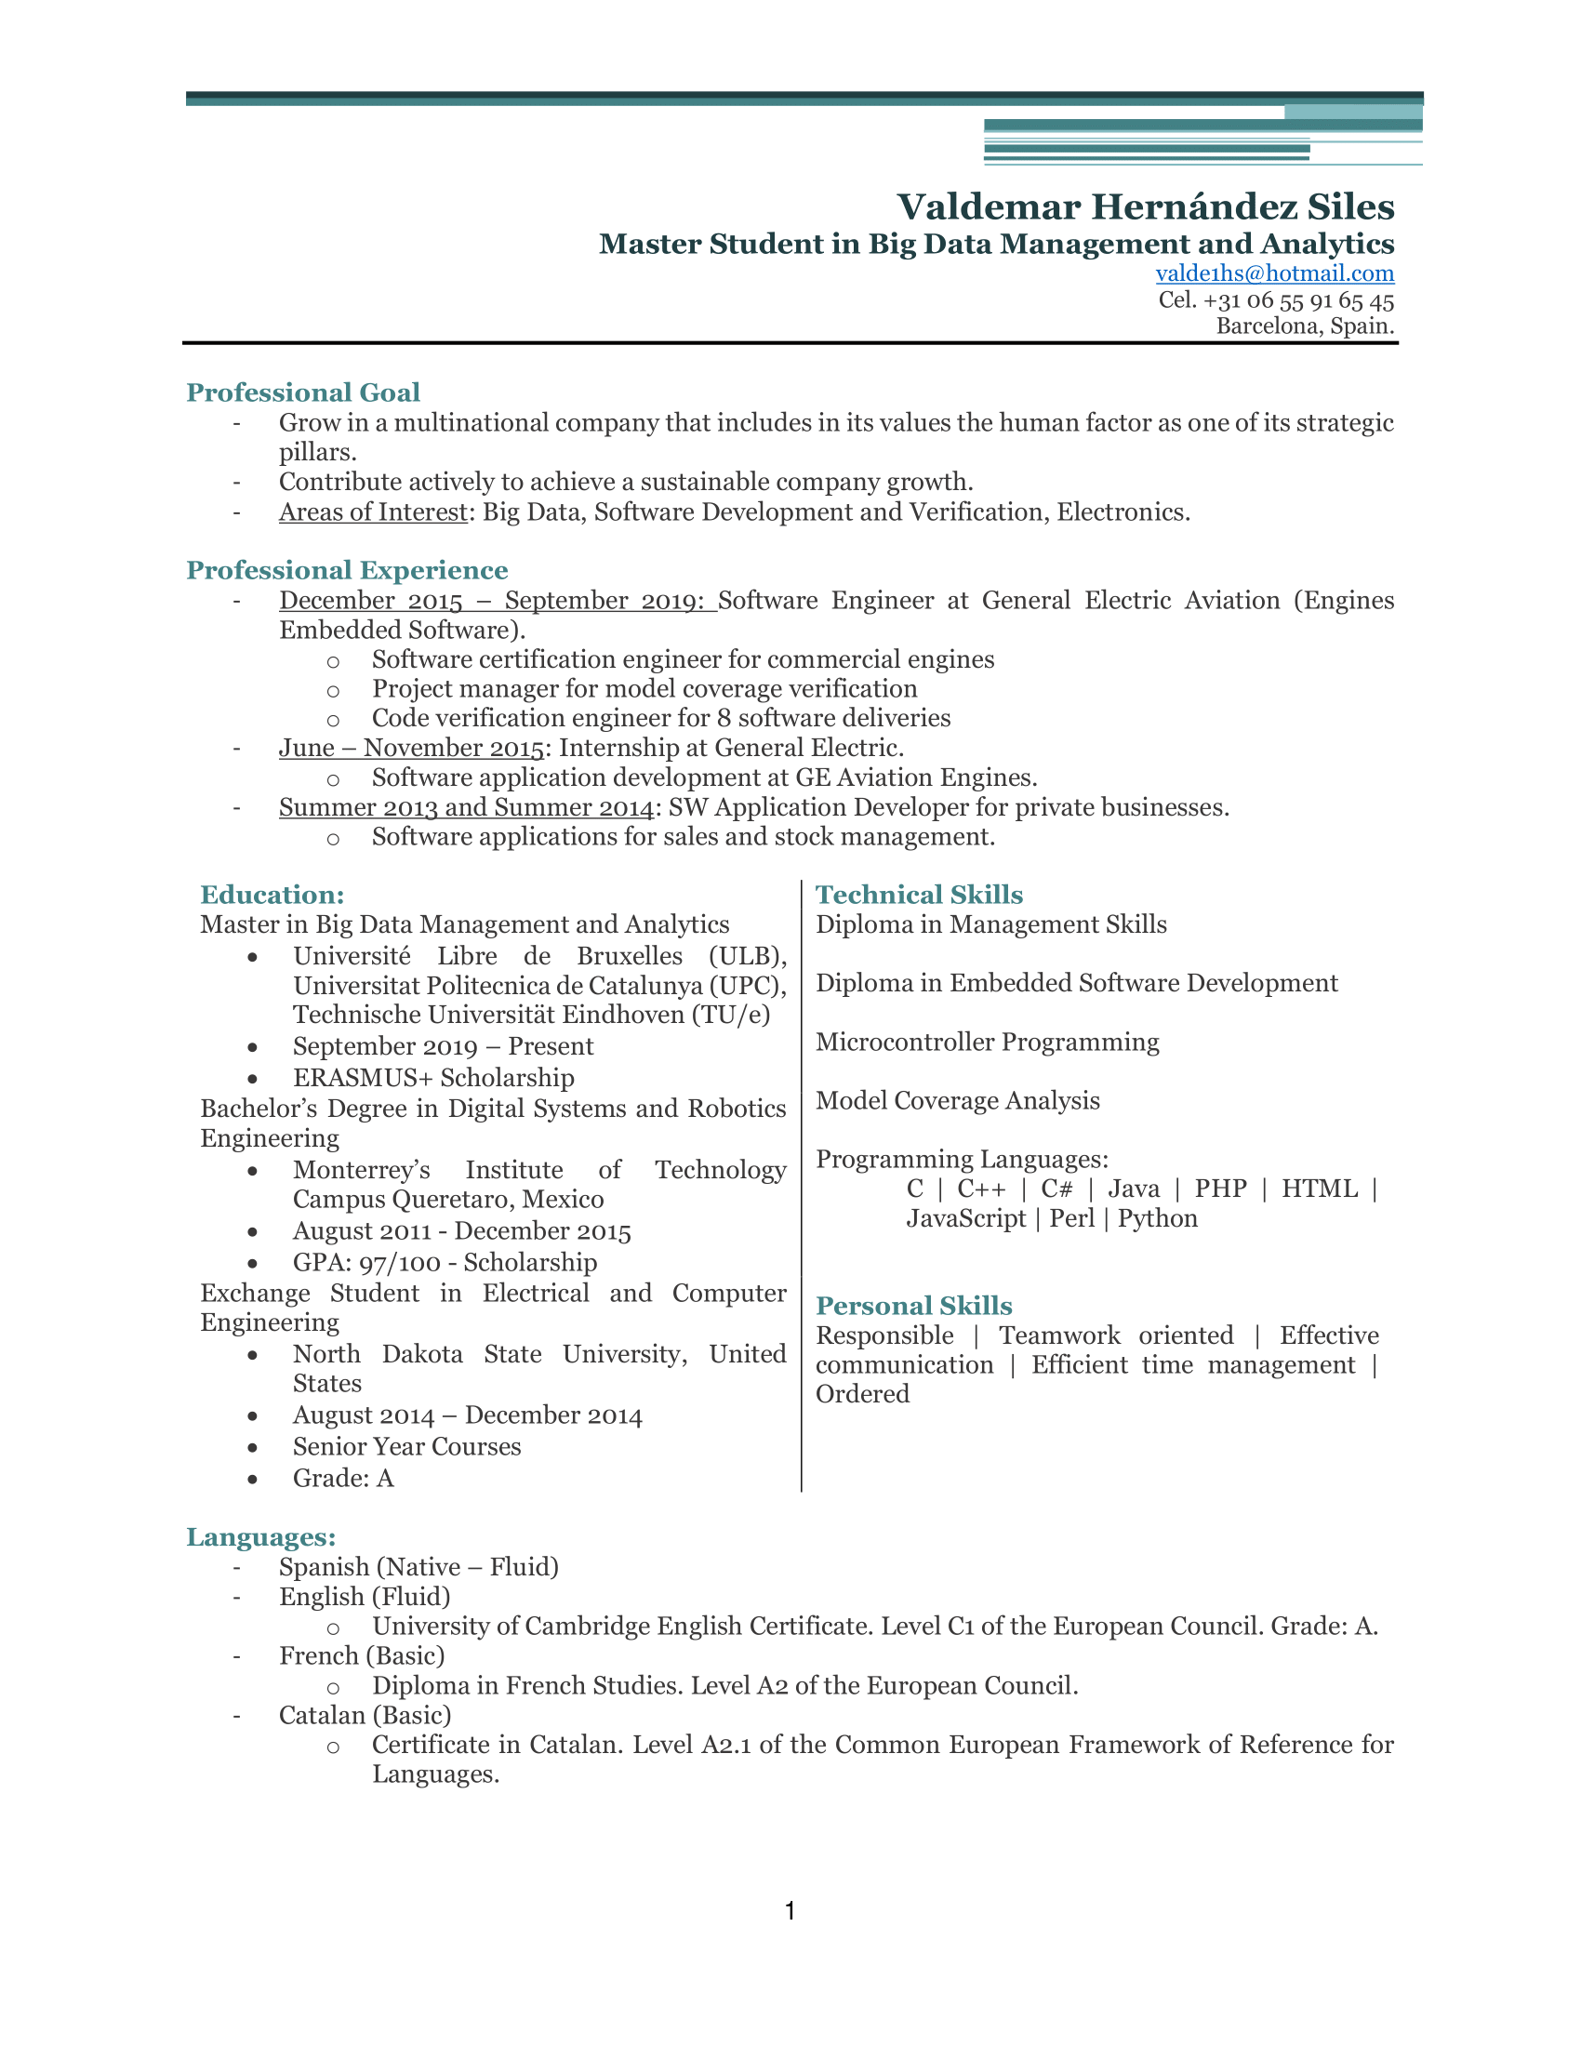

## C. Directors’ shares remuneration and contribution

The co-founders will be a part of the board of directors. As directors, each of the co-founders will contribute €7,500 as initial seed money. In return, they will receive remuneration in terms of stock.

Each director will have 12,000 stocks, which is equal to 12% of the total stock. At the end, this represents 60% of the total stocks for directors.

## D. Board of directors

The board of directors will consist of 6 people: the 5 co-founders and an external investor.

## E. Professional support services to hire

* Legal/Accounting services

We will need help with setting up the company. Afterwards, we will need help with the finance part of the company. We have allocated a budget of €3,000 as an initial cost for starting the company.

* Office rental

We have also allocated some funds for office rental.

# 

# 6. Business project beginning calendar (detailing the first 12 months).

The following two diagrams depict the different phases from the planification stage to the operational status of the comprehensive business idea of Sprout. The time horizon is around 12 months which represents the beginning of the project when the course started. Next to each phase, some comments have been added for more detail about budget, resources and risks.

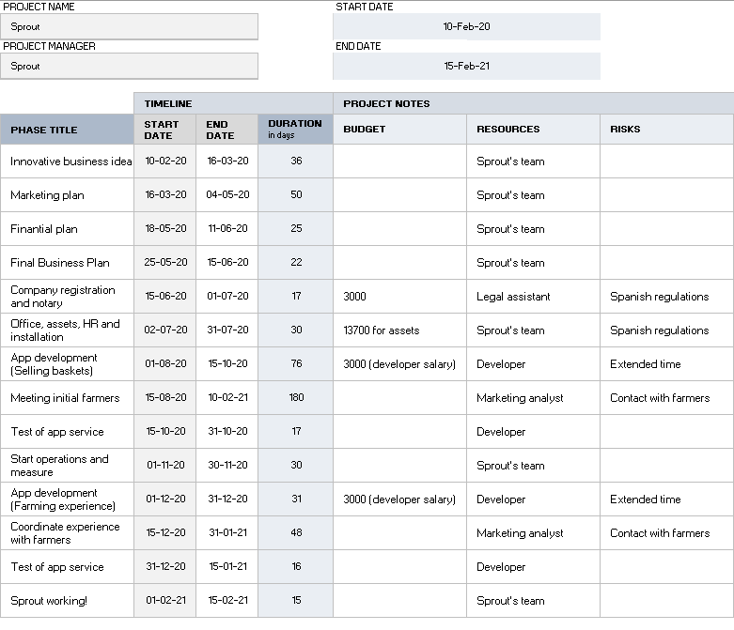

*Figure 14. Project Timeline*

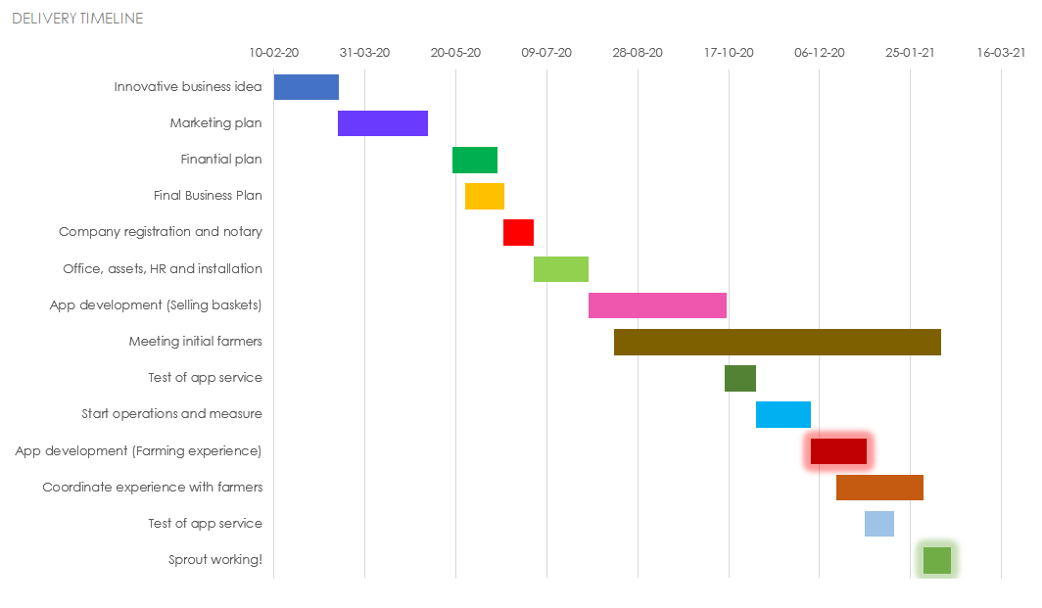

*Figure 15. Delivery Timeline*

# 7. Risks and critical problems we can find when implementing the plan and possible solutions.

For any startup company, there are several risks to consider and plan for before starting regular operations. These risks can be derived from several sources, such as uncertainties over market demand, actions of competitors or technological development. The book *Entrepreneurship* [14], suggests some strategies to address these risks, from which Sprout is considering the following:

* Market Scope Strategy: The market scope is a choice about which customer groups to serve and how to serve them, which in turn is determined by the risks that the company tries to reduce. For Sprout, the biggest risk to avoid is the competition with larger competitors, which, being in the food market, are not difficult to find. By applying a narrow-scope strategy, focusing on organic products, buying from local farmers and putting an emphasis on the quality, the company is able to differentiate from larger competitors, who must also focus on mass production. This strategy will allow the company to use its increased knowledge of the products to offer superior quality, which in turn will allow it to charge premium prices for the offered goods. In the best-case scenario, Sprout will position itself in a niche of high profit, not only evading the risk of competition with similar, bigger brands, but also providing a competitive advantage to the company.
* Imitation Strategy: Imitation involves copying practices from other firms, which, in the case of Sprout, refers to imitate the practices of successful firms in our business instead of spending too much time and resources trying to develop a whole new system, which carries with itself other risks if such system turns out to be flawed. Implementing an imitation strategy could provide the company with organizational legitimacy, so potential customers can view the company as a well-established business. This is not to say that Sprout will lose the factors that make the company stand out or put at risk its competitive advantage, it is rather a learning strategy for the company to identify what has worked well before and implement it in such a way that it allows a well-run operation so the distinctive factors can be its main focus.
* New Business Management: New organizations also run the risk of having too many liabilities derived simply from the fact that a new business is created. Employees may take time to develop the skills required by the company or perhaps responsibilities may not be well defined, or even if they are, unexpected situations are bound to surge that might not be considered initially. These situations require that Sprout establishes a set of processes and implements a training system so the required skills and knowledge about the company’s roles and procedures are learned quickly by the employees, which will help them to work on tasks more efficiently and avoid internal conflicts. If implemented correctly, this system will not only help the company avoid the risks associated with the start of a new business, but it will also allow it to take advantage of a clean slate to implement procedures that provide the flexibility to adapt for future changes that may occur in the food market industry, something that could make mature competitors struggle.

The following table shows Sprout’s Risk Matrix, providing additional details in the risks mentioned earlier as well as some additional potential risks and problems identified as of this report’s delivery, together with a more detailed description of the actions to be taken to address them should it be necessary.

| **Risk** | **Probability** | **Impact** | **Classification** | **Actions** |
| --- | --- | --- | --- | --- |
| Enter in direct competition with bigger companies | 3 | 4 | 12 | Focus on our differentiators: organic products of the highest quality and the farming experience, which is not provided by anyone else in the market. |
| The market changes and decreases the size and attractiveness of our market segment | 1 | 5 | 5 | This is not considered a big risk thanks to the market research performed, where the results indicate a recent trend for organic products. If it were to occur, we will reassess what type of products provide the best value through data analysis. |
| Trouble finding investors interested in the company | 2 | 4 | 8 | The initial investment by the founders could support operative costs for a couple of months. Also, bank loans are available for startup companies like Sprout that could provide the necessary funds for the first year of operations. |
| Hired employees underperform on their tasks (app development and maintenance, delivery service, etc.) | 2 | 3 | 6 | Put emphasis on the hiring process to make sure employees fit with the values and code of ethics established by the company. Also, reinforce training for new employees to make sure they are ready for the tasks. |
| Trouble finding farmers willing to partner with the company | 2 | 4 | 8 | Initial research suggests this will not be an issue, with Barcelona (and Catalunya in general) having an important role in the production of organic products. However, if this occurs, we will expand our working radius to find more potential partners, putting an emphasis in the benefits this entails. |
| Amount of customers who sign up in the app is less than expected | 3 | 2 | 6 | Monitor customers who use the app and reevaluate benefits of signing up and becoming a VIP customer to incentivize customers to take advantage of it. |
| Promotion strategies do not reach expected number of customers | 2 | 2 | 4 | Analyze marketing strategy and increase the marketing budget if possible. |

# 

# 8. Financial Plan

## A. Profit & Loss Statement Forecast (2-3 years).

Here is a list of the products and prices we are considering when doing our financial plan:

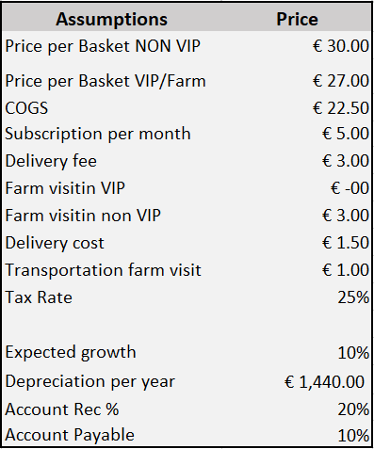

*Figure 16. Products and Prices*

As we can see, our VIP clients have a discount of 10% on their purchases and since they are our most loyal clients, we have also considered monthly payments. This is named as account receivable and it will be equal to 20% of our revenue. Another assumption we have made is related to our payments. We are going to consider as “account payable” 10% of our expenses.

Apart from them we also have one time expenses which are the below ones:

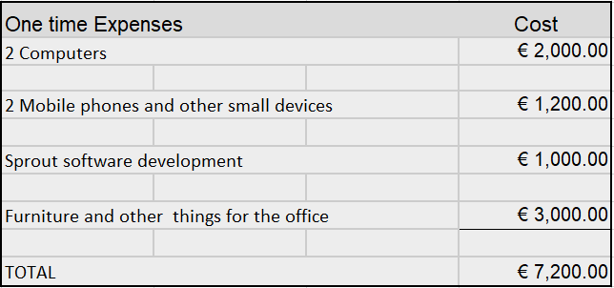

*Figure 17. One time expense*

For all these items, we are assuming a straight line amortization and a longevity of 5 years per product. Their residual value will be zero, so at the end of the fifth year, their value will be zero.

This our income statement for the next three years.

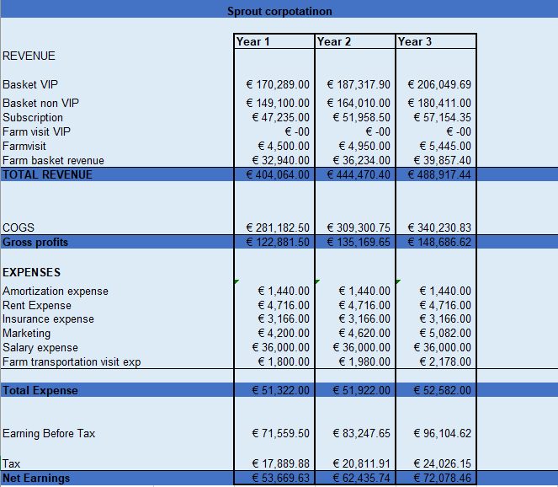

*Figure 18. Income Statement*

We are assuming a growth of 10% after each year and this is reflected on the net profit values. Apart from that, during these three years we are not assuming new hirings or more fixed expenses.

## B. Treasury Forecast (for the first 12 months).

Talking about the cash flow, we are making a detailed overview:

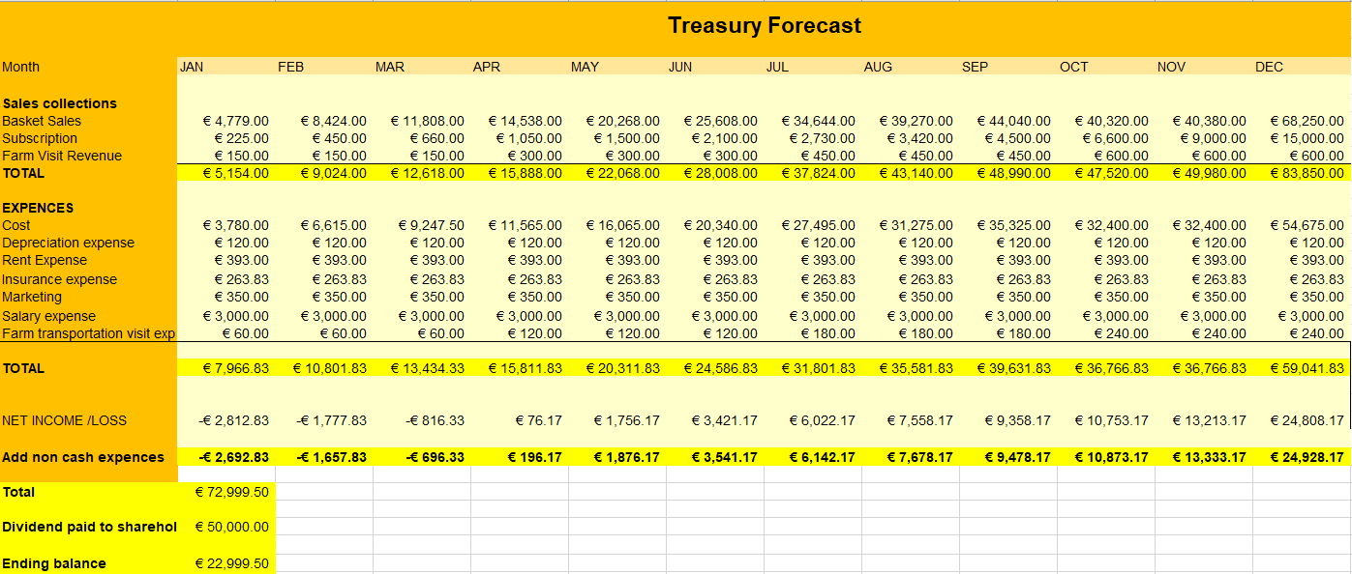

*Figure 19. Treasury Plan*

As a new business, we are assuming we will generate losses in the first three months until we build a small clients portfolio. Things will start looking better after the third month because on the forth we start covering our costs and generating a small profit. Having into consideration the initial investment that we are going to do, a part of the total will be divided among shareholders and the remaining will be used for the next year. This value is represented in our balance sheet as treasury.

## C. Balances Sheet Forecast (2-3 years).

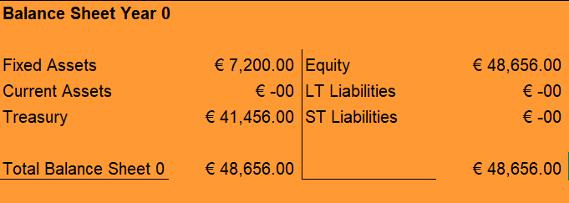

*Figure 20. Balance Sheet for Year 0*

To cover for the first 6 months of operations Sprout will require €48,656.00, which also includes our fixed assets.

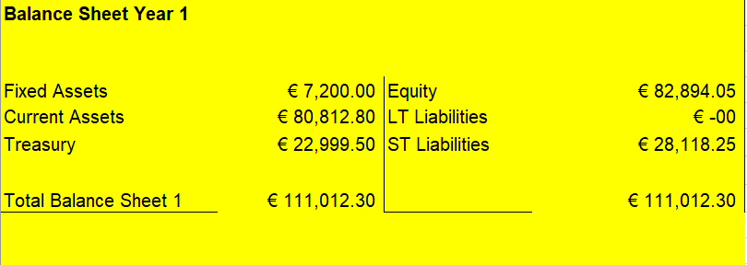

*Figure 21. Balance Sheet for Year 1*

In the first year, our fixed asset will have the initial value, the current assets are equal to 20% of the account receivable and the treasury mentioned in the treasury plan. The equity will be our initial investment plus our treasury value. The loan that we have to pay is calculated to be paid in 5 years. That's why every year, its value decreases by 20%. The same logic is followed in all the balance sheets.

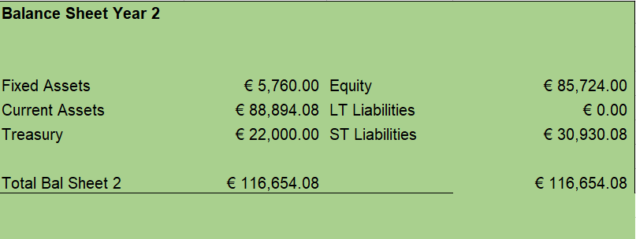

*Figure 22. Balance Sheet for Year 2*

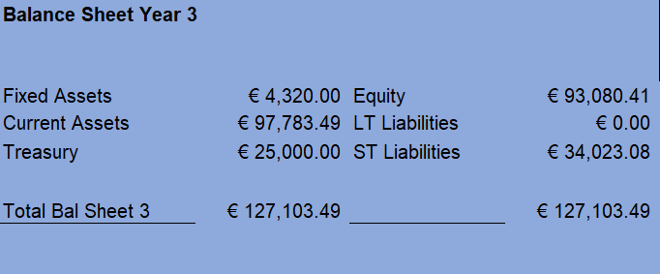

*Figure 23. Balance Sheet for Year 3*

## D. Break-even analysis (first year).

Considering our financial study, we have to find out the amount of products we need to sell to have zero loss and zero profit. We are scaling up by 2000 units and here is the graph:

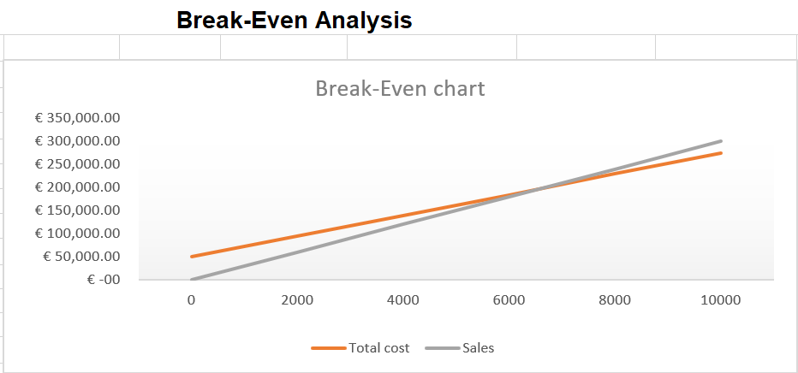

*Figure 24. Break-Even Chart*

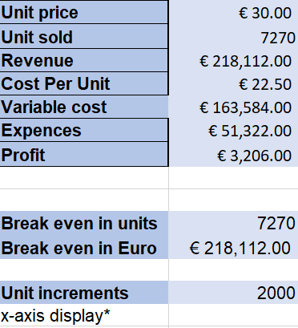

*Figure 25. Break-Even Analysis*

According to our result, we need to sell 7270 units in order to cover all our costs.

## E. How we will manage Cost Control (description of the system to use).

Whenever a new project starts, we need to talk and discuss its cost management. To have a clear picture of the cost we need to go through three main stages: cost estimation, cost budgeting and cost control. In our case, we have already finished with the first two phases, so we need to think about a strategy on how to manage cost control. Before doing that, we need to have some initial information where we can see the cost baseline, the performance reports, the work performance information, the project management plan and the requested changes. Since we are a business offering a service to our clients, it will be very important for us to keep track of our performance and client’s feedback and also to build a strong relationship with our suppliers. This is why we are going to analyse our information every month. We will for sure be vigilant regarding our competitors and we will revise and change, if needed, our contracts every year. If there are proposed changes, we will discuss and approve the ones that help us grow on a monthly basis.

There is another important factor to be considered when talking about costs. This is forecasting. We will do and use it to check whether we are moving as we planned. As business grows, the expenses grow, so we will keep in mind that the variable expenses are the ones that generate profit to our company so we will choose them above the fixed expenses.

The result of this process will provide us updated information regarding cost estimate and cost baseline, recommended corrective actions and performance measurements.

# 

# 9. Proposal for the investors

## A. Financial needs through other shareholders (different than founders).

Founders will contribute €7,500.00 each from personal savings, however, for the first 6 months of operation, Sprout requires a total of €48,656.00. The €11,156.00 that we’re missing will be obtained from private financing, more specifically, from business angels.

The money obtained from these angel investors will be used for start-up financing, this is, to help get company operations started. The details on the needs that will be addressed by this funding are mentioned in 8. Financial Plan.

## B. Final composition of shareholders

Equity will be divided between 3 main groups, Sprout’s founders, investors and an Option group, which will be the percentage assigned to other contributors such as directors, advisors and employees [15]. The equity percentage assigned to each of them is detailed in the diagram below.

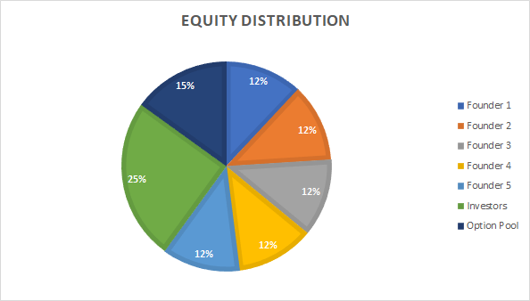

*Figure 26. Equity Distribution*

Based on these percentages and the details of the financial plan, it is possible to calculate the projected profit for all the shareholders after the first year of Sprout’s operations.

| **Shareholder** | **Total Profit** | **Percentage** | **Profit** |
| --- | --- | --- | --- |
| Ariston Lim | €50,000.00 | 12.00% | €6,000.00 |
| Hung Nguyen | 12.00% | €6,000.00 |
| Julio Candela | 12.00% | €6,000.00 |
| Nejada Karriqi | 12.00% | €6,000.00 |
| Valdemar Hernandez | 12.00% | €6,000.00 |
| Investors | 25.00% | €12,500.00 |
| Option Pool | 15.00% | €7,500.00 |

To calculate the return on investment (ROI) for investors, it is only necessary to divide the profit assigned to them on Year 1 by their initial investment of €11,456.00.

**ROI (Year 1) = 12500 / 11156 = 112.05%**

**Letter for Investors**

The following page contains a sample letter containing our proposal for potential investors:

Sprout

Barcelona, Spain

Phone: (+34) 12 345 6789

Email: vhernandez@sprout.com

June 15th, 2020

Dear [Investor]:

We write this letter to make you a proposal related to the future of our company, so you can be part of our vision and success.

A few months ago, inspired by the “Zero Hunger” goal of the United Nations’ Sustainable Development, we decided to create Sprout, a startup company that helps to achieve this objective by supporting local farmers and making sustainable food choices. Our vision is to transform how we grow, share, and consume our food.

We will be offering two products, local produce and a farm visit experience. Through our app and website, customers will be able to order a customized basket of products originated from our select group of suppliers, which we make sure practice sustainable farming and promote ecological balance. With our second product, we try to educate our customers about these positive practices, allowing them to see where their food comes from and how it is produced.

For the first 3 years, we are planning to operate in Barcelona and its surroundings, where we know there is a large market for organic products and there is no other company that offers the two products we want to provide to our customers.

We are seeking a financing of €11,156.00, largely to cover our start-up costs such as marketing expenses and salaries for the first 6 months. We, the five founders of Sprout, are investing €7,500.00 from our personal savings as well. As an investor, you will receive 25% of the company’s shares, which, by the end of the first year, will represent a ROI of approximately 112.05%, which we know will increase in the following years, since Sprout is projected to grow 10% annually for the 2nd and 3rd year of operations.

Attached to this letter you can find a copy of our business plan. We appreciate your time and please do not hesitate to contact us with any questions you might have.

Sincerely,

The Sprout Team

# References

[1] Gil J.M., Gracia A, Sánchez M. (2001). Market segmentation and willingness to pay for organic products in Spain. International Food and Agribusiness Management Review

[2] European Commission (2018). The EC Megatrends Hub. Retrieved from: <https://ec.europa.eu/knowledge4policy/foresight/about_en>

[3] Organic Food Iberia (2018). Quarterly reports on the Spain’s organic sector. Retrieved from: <https://www.organicfoodiberia.com/news/el-lanzamiento-del-sector-ecologico-de-espana-2/>

[4] Elghannam, Ahmed. (2013). The Consumption of Organic Food in Spain: Application of Conjoint Analysis to estimate consumer preferences. 10.13140/RG.2.1.4653.7200.

[5] Forbes, P. (June, 2014). Dan Barber on Why the Farm-to-Table Movement Doesn't Go Far Enough. Eater. Retrieved from: <https://www.eater.com/2014/6/12/6208269/dan-barber-on-why-the-farm-to-table-movement-doesnt-go-far-enough>

[6] MindTools (2016). How to Develop a Strategy For Success. Retrieved from: <https://www.mindtools.com/pages/article/newTMC_05.htm>

[7] European Commission (2019). The fruit and vegetable sector in the EU - a statistical overview. Retrieved from:

<https://ec.europa.eu/eurostat/statistics-explained/pdfscache/53634.pdf>

[8] The Seattle Times (2010). How often do you need to buy vegetables?. Retrieved from: <https://www.seattletimes.com/life/food-drink/how-often-do-you-need-to-buy-vegetables/>

[9] *Goal 2: Zero Hunger*. UN Sustainable Development Goals. Retrieved from: <https://www.un.org/sustainabledevelopment/hunger/>

[10] Bosch, Sofia (2017). Here’s how bad economically a Spain-Catalonia split could really be. CNBC. Retrieved from <https://www.cnbc.com/2017/09/21/heres-how-bad-economically-a-spain-catalonia-split-could-really-be.html>

[11] Agricultura Ecológica Estadísticas 2018 (2019). MINISTERIO DE AGRICULTURA, PESCA Y ALIMENTACIÓN. Retrieved from <https://www.mapa.gob.es/es/alimentacion/temas/produccion-ecologica/estadisticaspe2018_tcm30-513741.pdf>

[12] Nasir, V. Aslihan & Karakaya, Fahri. (2014). Consumer segments in organic foods market. Journal of Consumer Marketing. 31. 10.1108/JCM-01-2014-0845. Retrieved from <https://www.researchgate.net/publication/265969293_Consumer_segments_in_organic_foods_market>

[13] World Map of Social Networks (2020). Retrieved from

<https://vincos.it/world-map-of-social-networks/>

[14] Hisrich, R., Peters, M., Shepherd, D. (2017). *Entrepreneurship* (10th edition). McGraw-Hill Education.

[15] Kazanas, D. (August, 2015). *How to Divide Equity Among Startup Founders, Investors, Directors, Advisors, and Employees*. LinkedIn. Retrieved from: <https://www.linkedin.com/pulse/how-divide-equity-among-startup-founders-investors-advisors-kazanas/>